**Problem 1:** Vehicle Fleet Management System

**Requirements**: Create a structure Vehicle with the following members:

char registrationNumber[15], char model[30], int yearOfManufacture ,float mileage,float fuelEfficiency

**Implement functions to:**

Add a new vehicle to the fleet.

Update the mileage and fuel efficiency for a vehicle.

Display all vehicles manufactured after a certain year.

Find the vehicle with the highest fuel efficiency.

Use dynamic memory allocation to manage the fleet of vehicles.

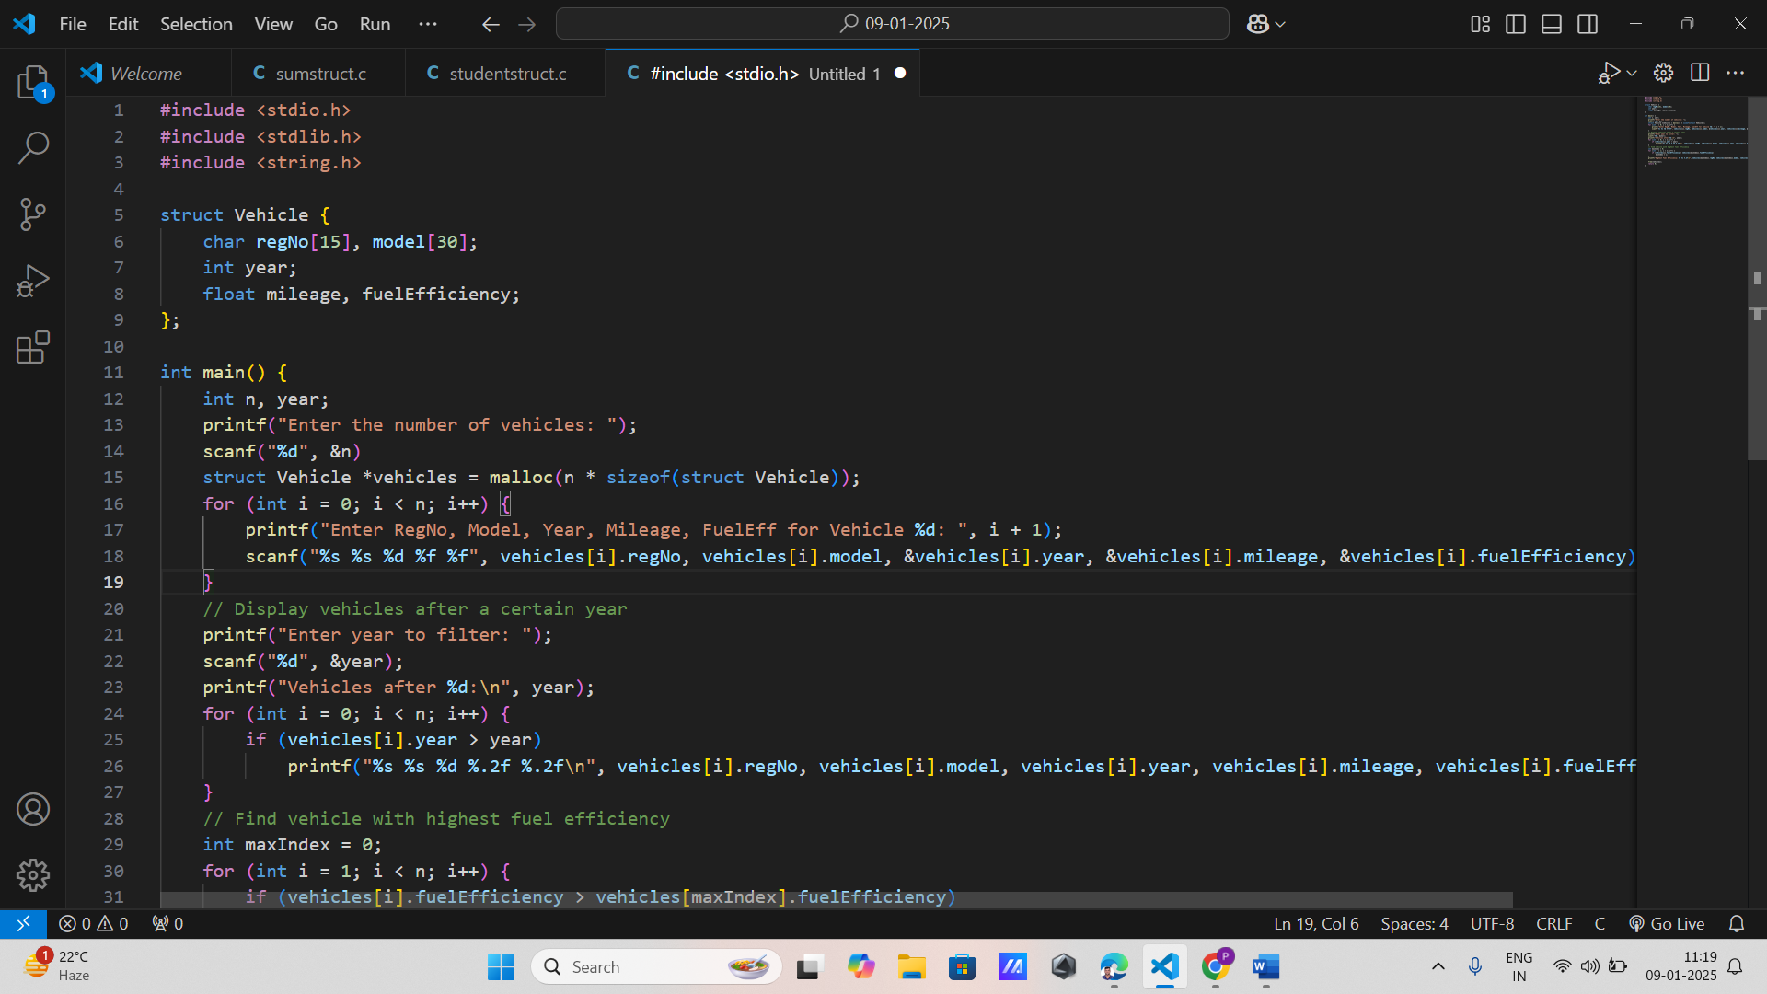

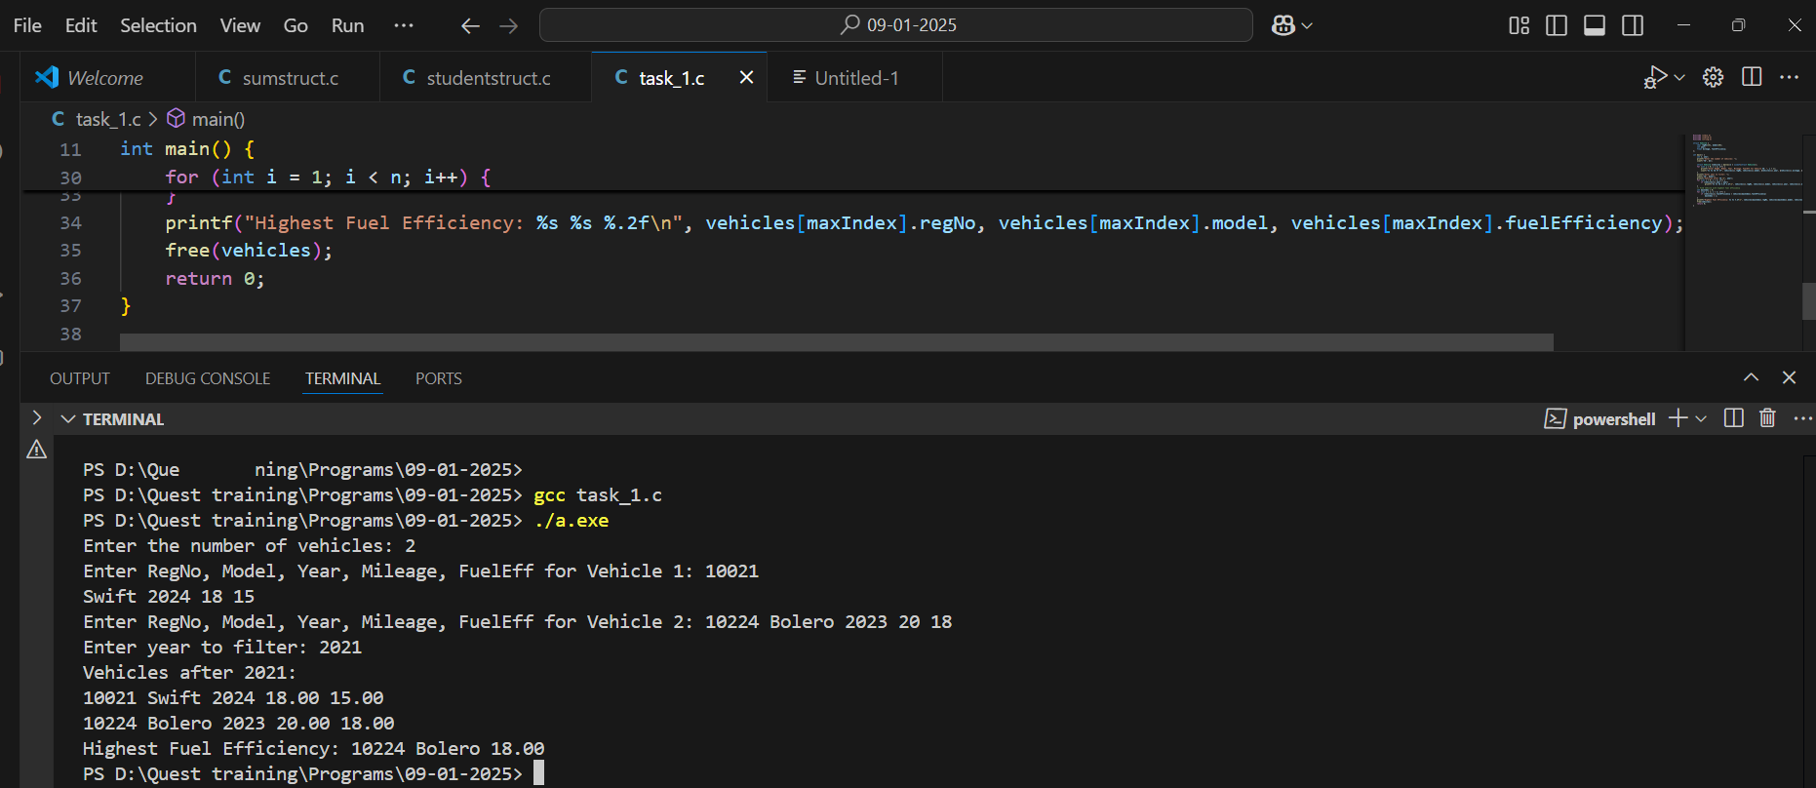

**Problem 2:** Car Rental Reservation System

**Requirements:**

Define a structure CarRental with members: char carID[10], char customerName[50], char rentalDate[11] (format: YYYY-MM-DD), char returnDate[11], float rentalPricePerDay,

**Write functions to:** Book a car for a customer by inputting necessary details.

Calculate the total rental price based on the number of rental days.

Display all current rentals. Search for rentals by customer name.

Implement error handling for invalid dates and calculate the number of rental days.

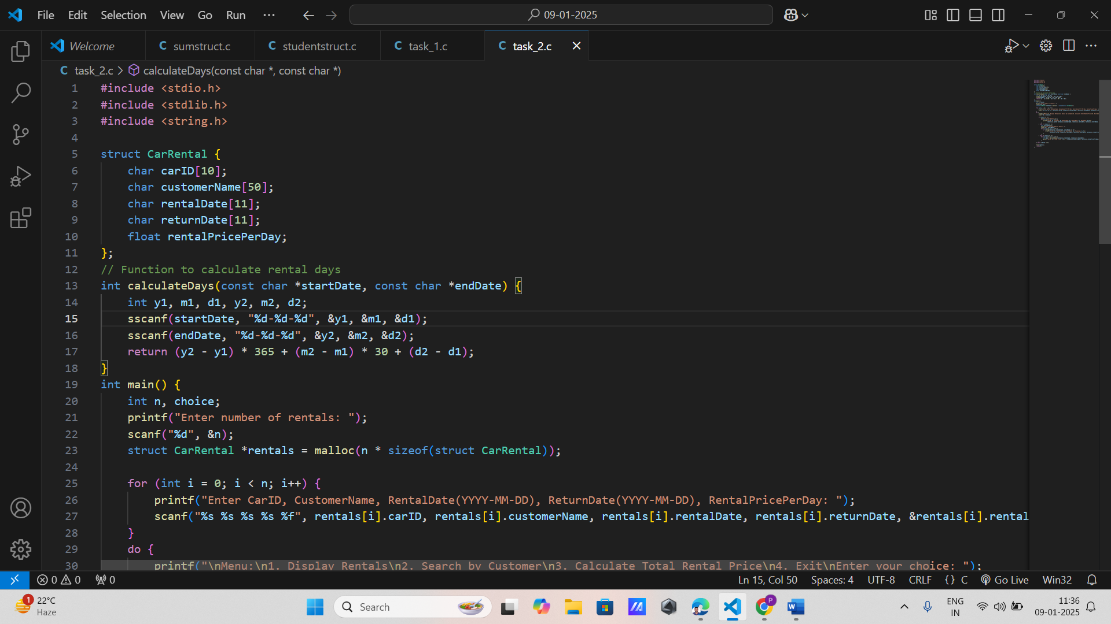

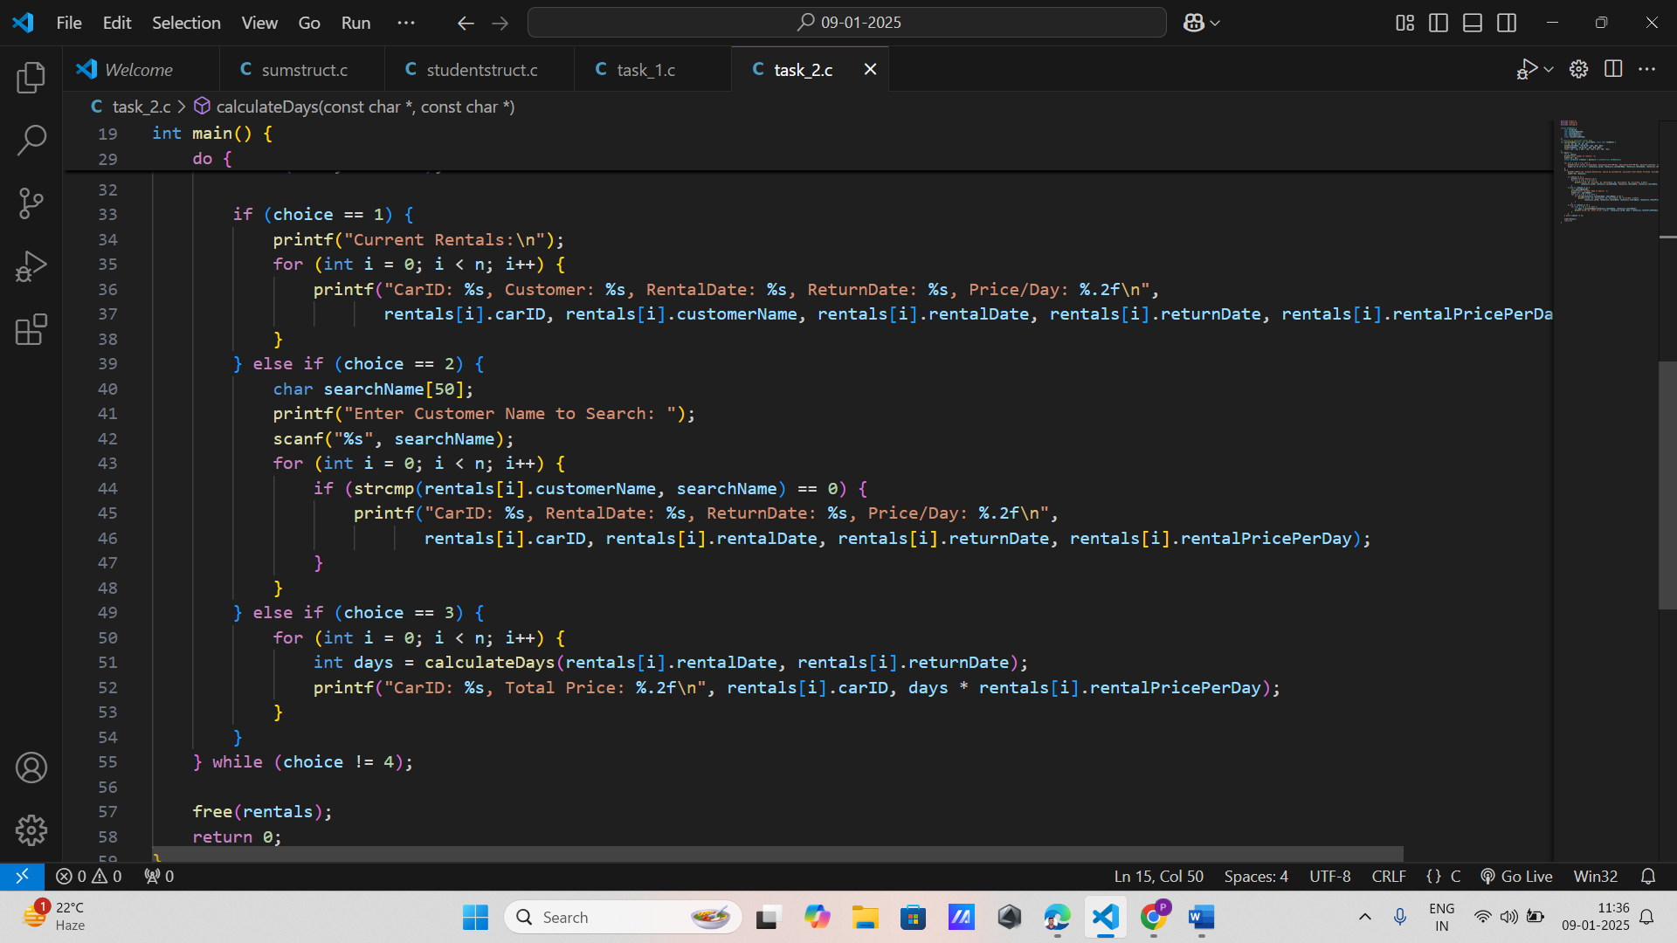

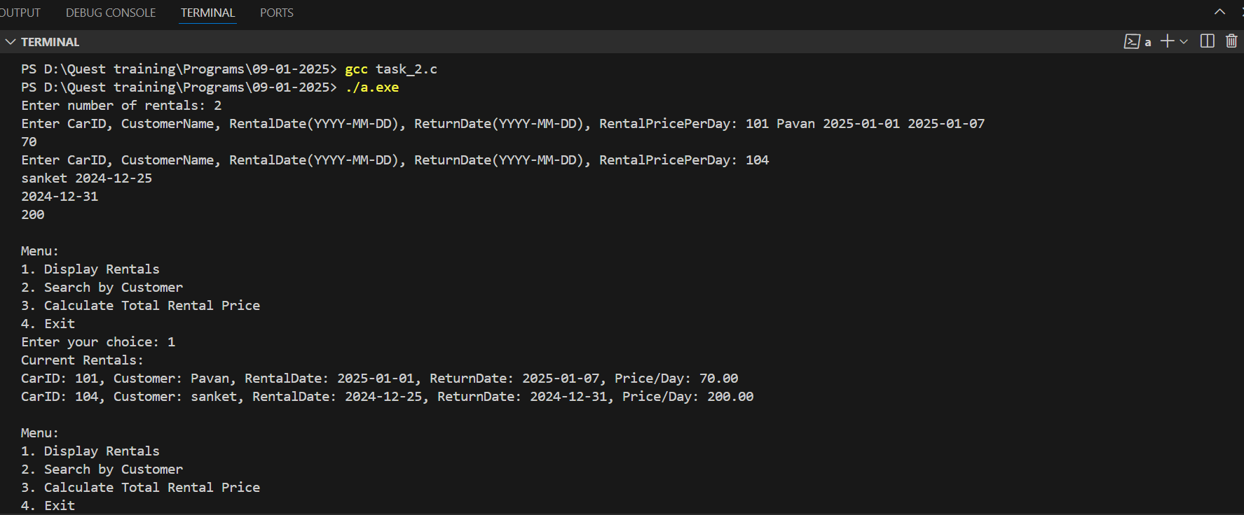

**Problem 3:** Autonomous Vehicle Sensor Data Logger

**Requirements:**

Create a structure SensorData with fields: int sensorID, char timestamp[20] (format: YYYY-MM-DD HH:MM:SS), float speed, float latitude, float longitude,

**Functions to**:

Log new sensor data. Display sensor data for a specific time range. Find the maximum speed recorded. Calculate the average speed over a specific time period. Store sensor data in a dynamically allocated array and resize it as needed.

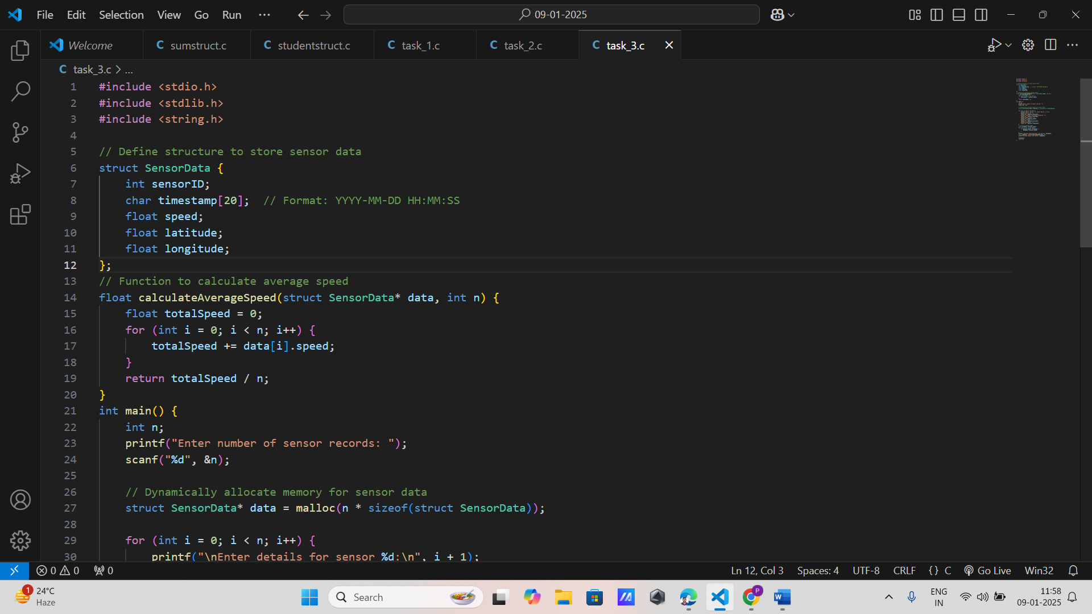

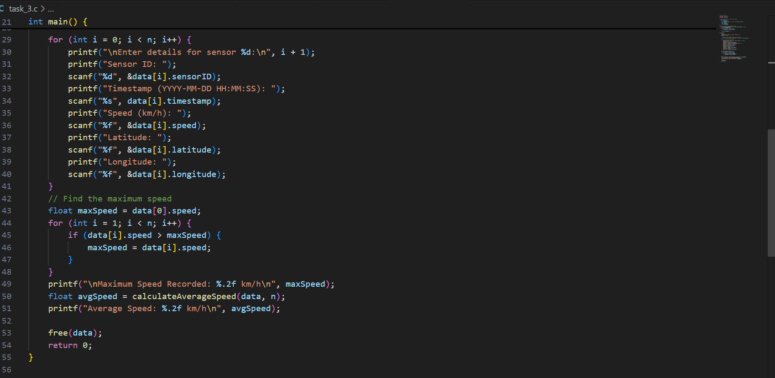

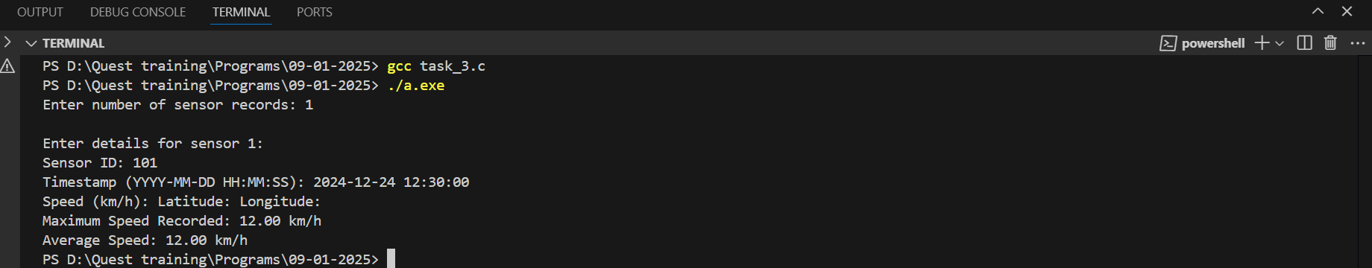

**Problem 4:** Engine Performance Monitoring System

**Requirements**: Define a structure EnginePerformance with members: char engineID[10], float temperature, float rpm, float fuelConsumptionRate, float oilPressure,

**Functions** to: Add performance data for a specific engine.

Display all performance data for a specific engine ID.

Calculate the average temperature and RPM for a specific engine.

Identify any engine with abnormal oil pressure (above or below specified thresholds).

Use linked lists to store and manage performance data entries.

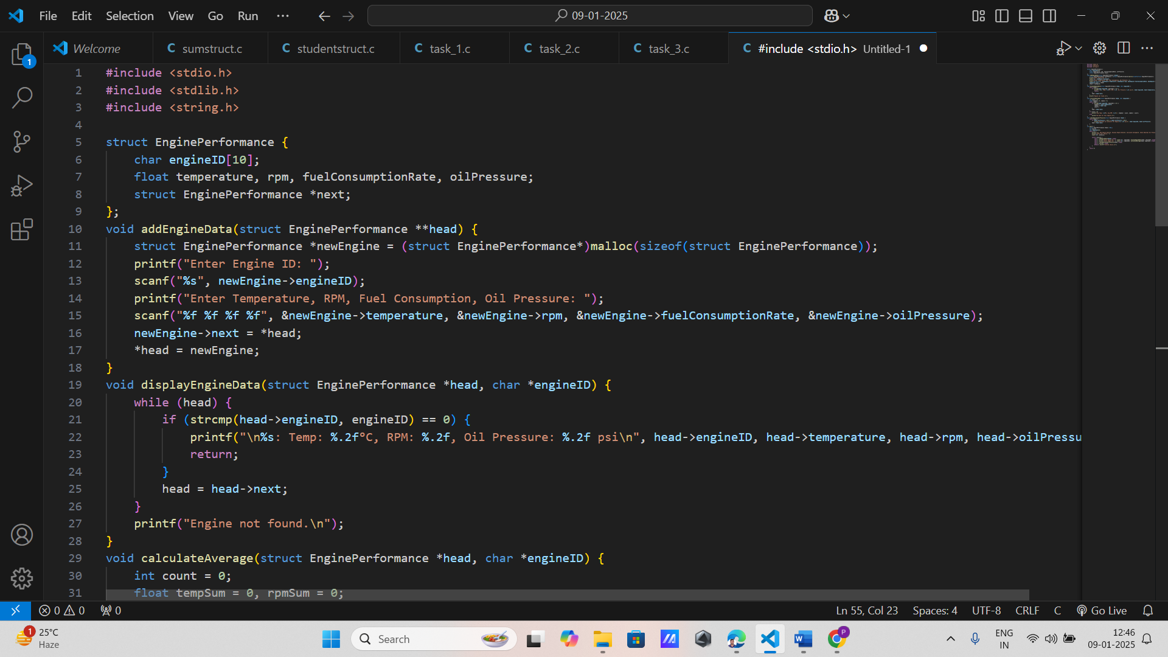

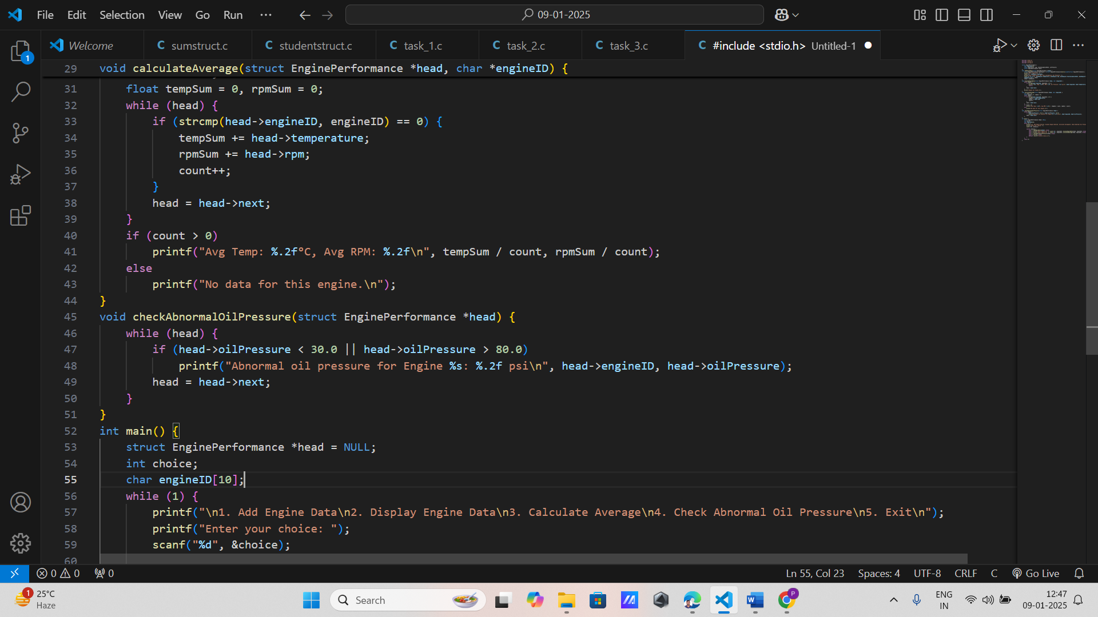

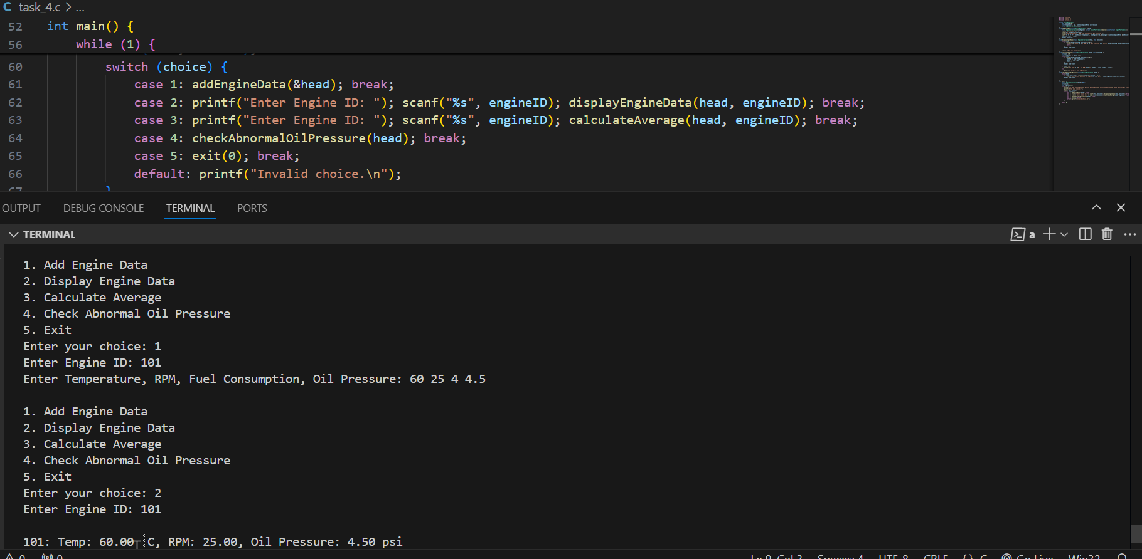

Problem 5: Vehicle Service History Tracker

Requirements: Create a structure ServiceRecord with the following: char serviceID[10], char vehicleID[15], char serviceDate[11], char description[100], float serviceCost,

Functions to:1. Add a new service record for a vehicle.2. Display all service records for a given vehicle ID.3. Calculate the total cost of services for a vehicle.4. Sort and display service records by service date.

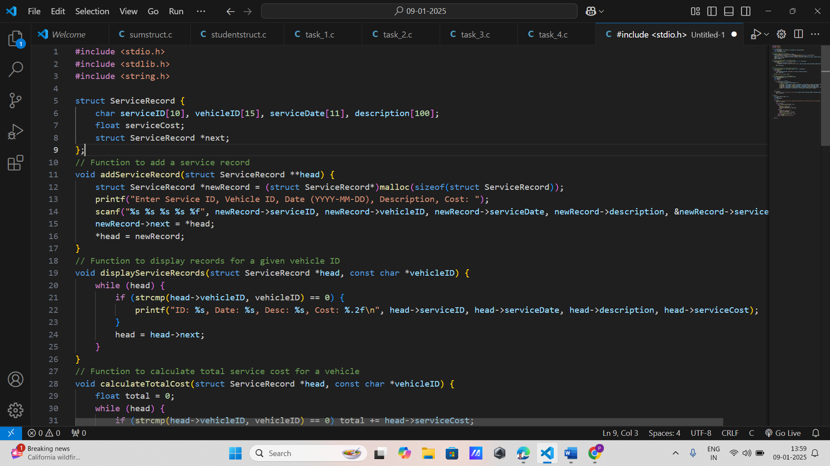

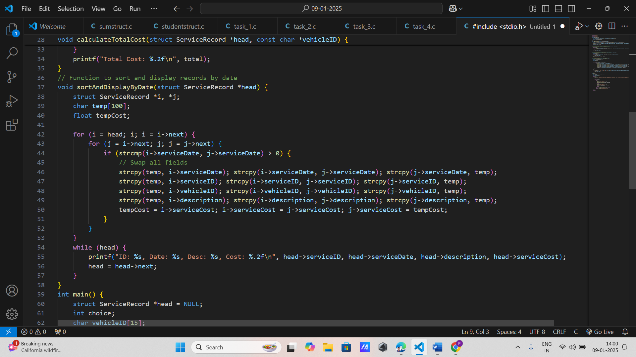

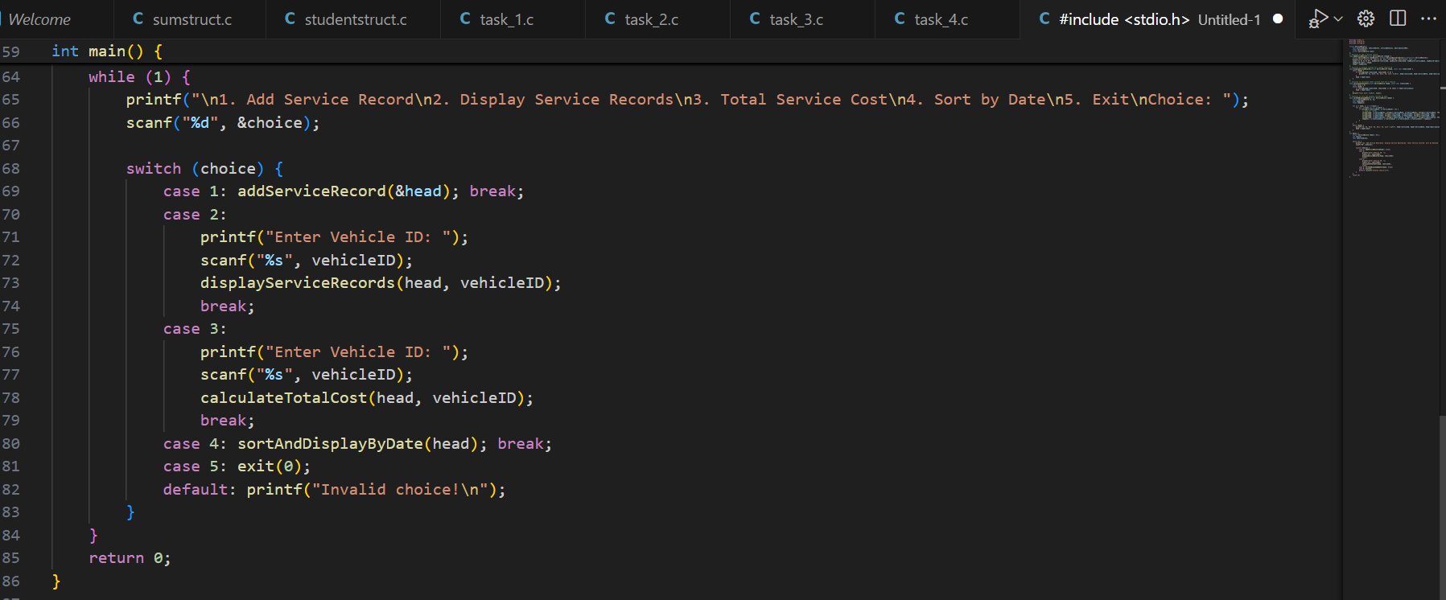

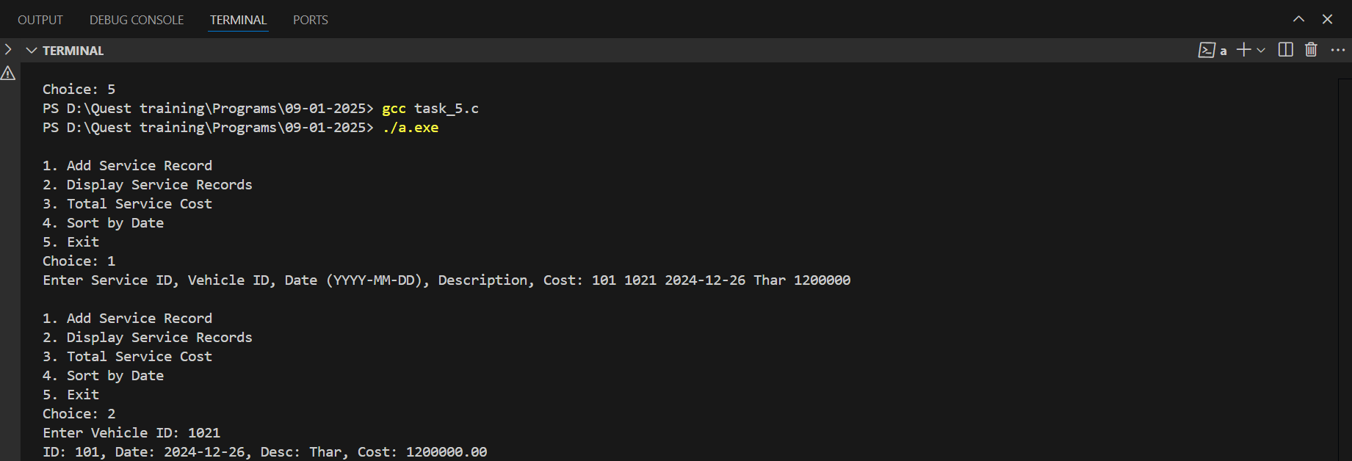

**Problem 1: Player Statistics Management**

**Requirements:**

* Define a structure Player with the following members:
  + char name[50]
  + int age
  + char team[30]
  + int matchesPlayed
  + int totalRuns
  + int totalWickets

**Functions to:**

* Add a new player to the system.
* Update a player’s statistics after a match.
* Display the details of players from a specific team.
* Find the player with the highest runs and the player with the most wickets.
* Use dynamic memory allocation to store player data in an array and expand it as needed.

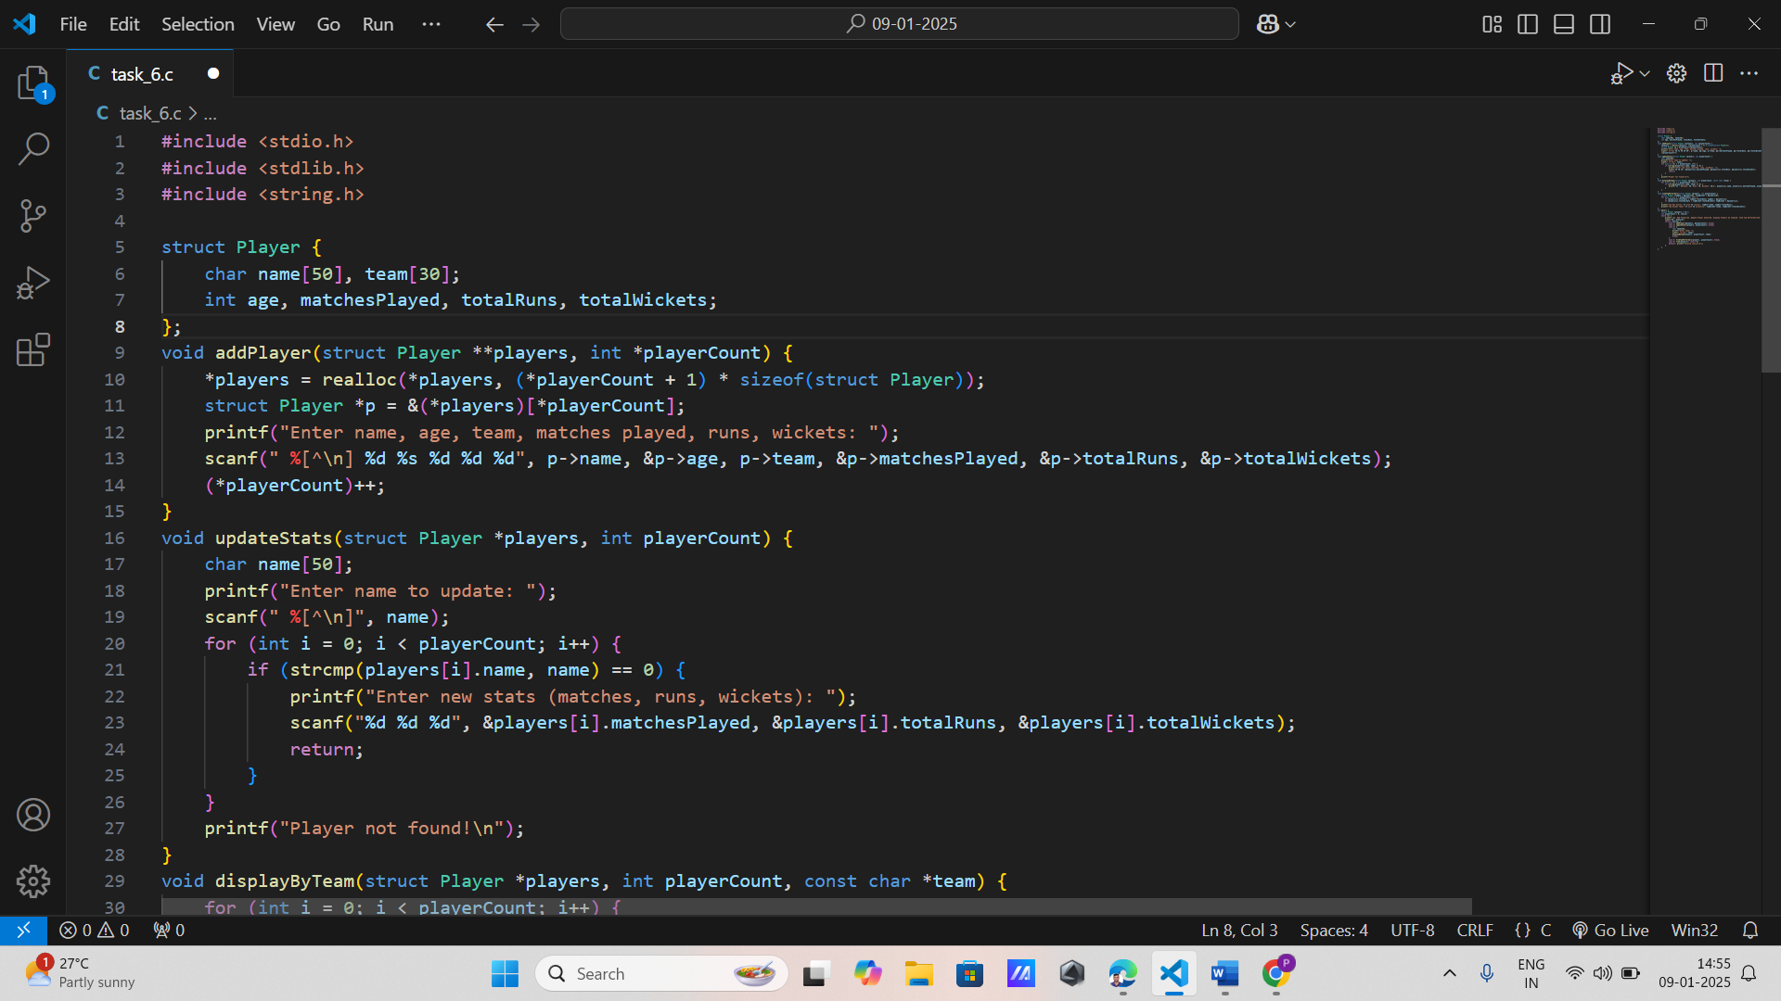

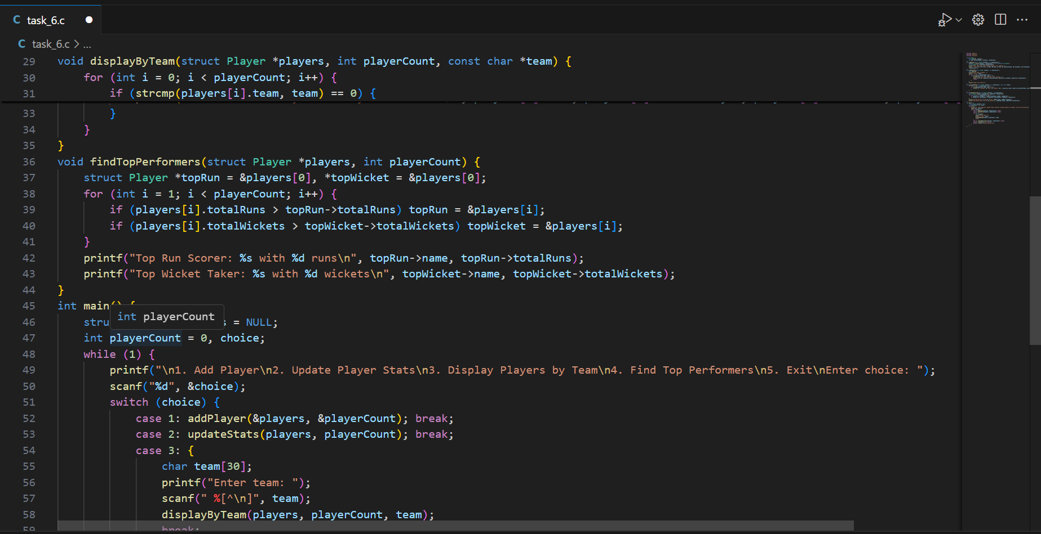

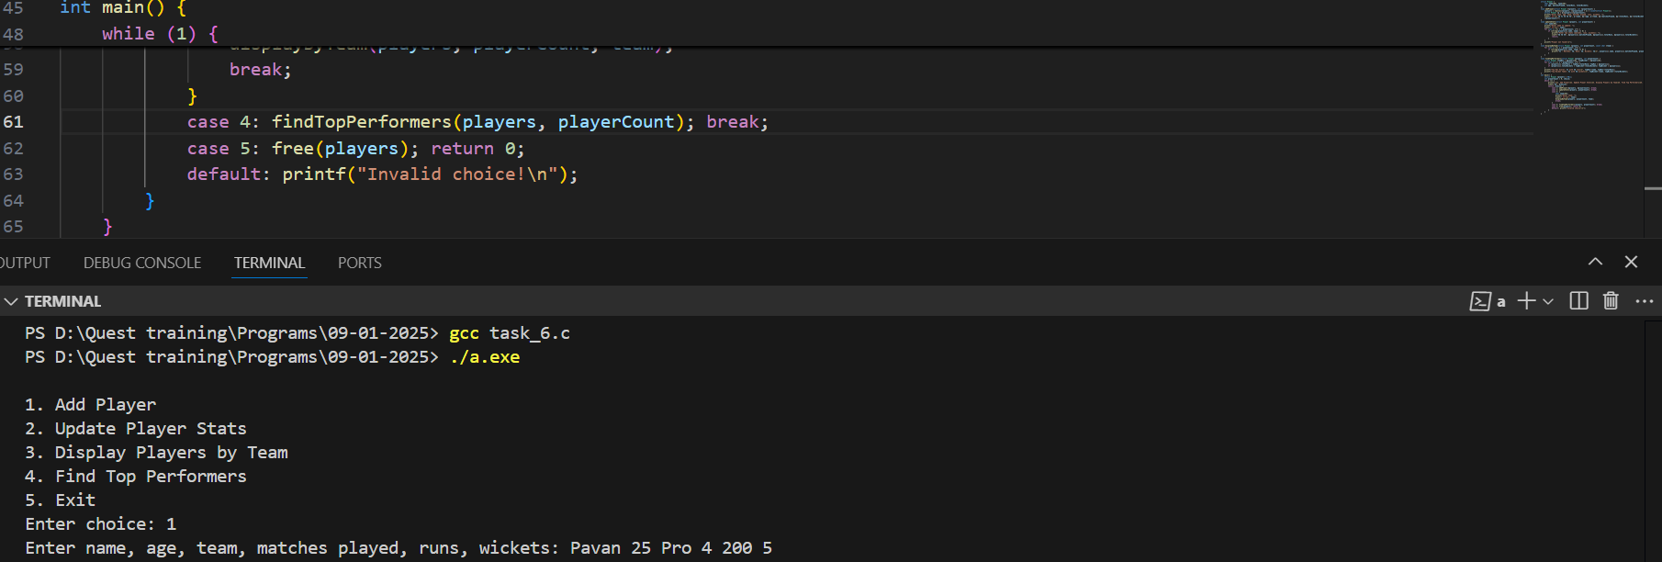

**Problem 2: Tournament Fixture Scheduler**

**Requirements:**

* Create a structure Match with members:
  + char team1[30]
  + char team2[30]
  + char date[11] (format: YYYY-MM-DD)
  + char venue[50]

**Functions to:**

* Schedule a new match between two teams.
* Display all scheduled matches.
* Search for matches scheduled on a specific date.
* Cancel a match by specifying both team names and the date.

Ensure that the match schedule is stored in an array, with the ability to dynamically adjust its

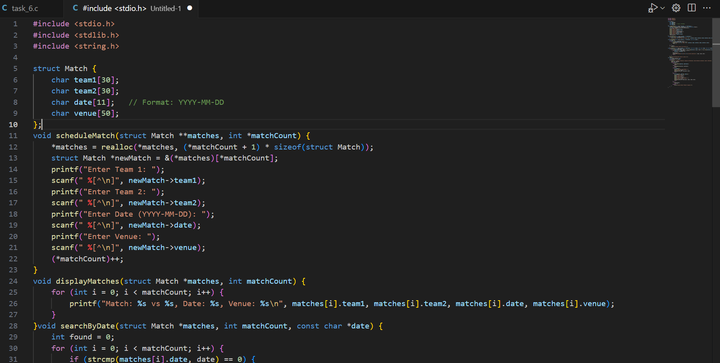

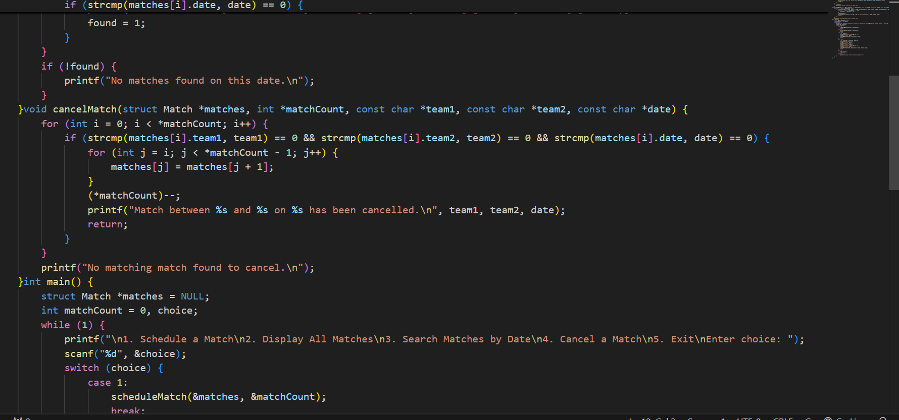

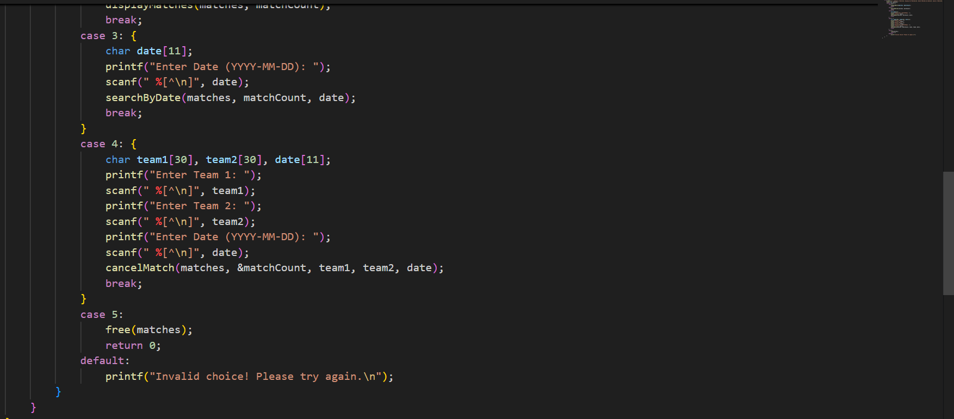

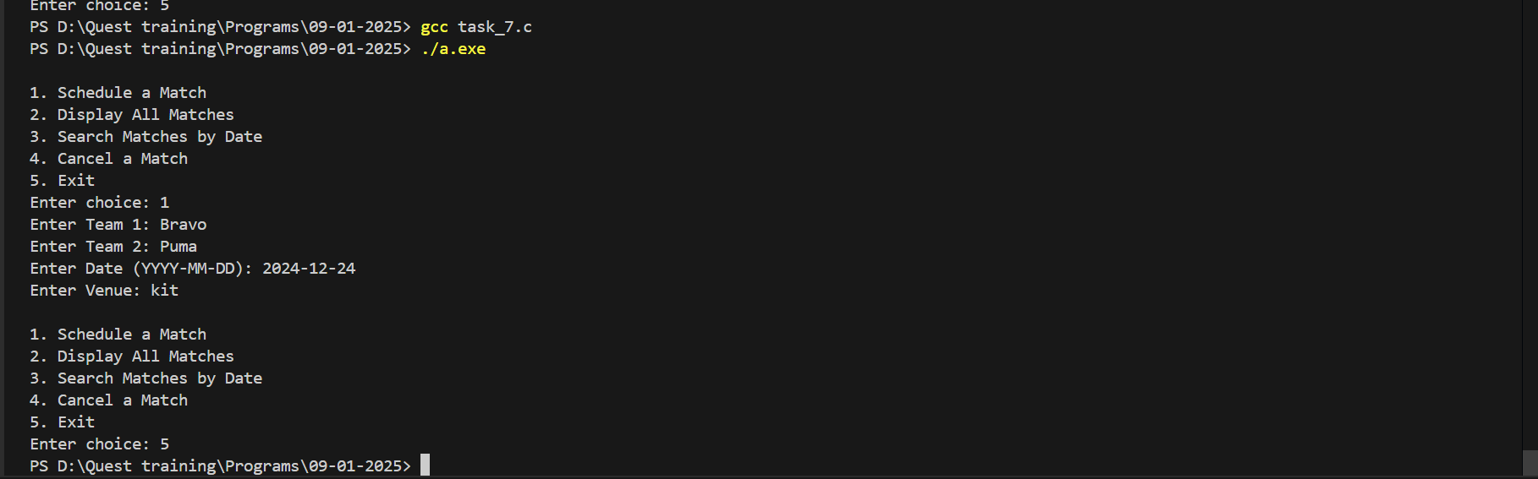

**Problem 3: Sports Event Medal Tally**

**Requirements:**

* Define a structure CountryMedalTally with members:
  + char country[30]
  + int gold
  + int silver
  + int bronze

**Functions to:**

* Add a new country's medal tally.
* Update the medal count for a country.
* Display the medal tally for all countries.
* Find and display the country with the highest number of gold medals.
* Use an array to store the medal tally, and resize the array dynamically as new countries are added.

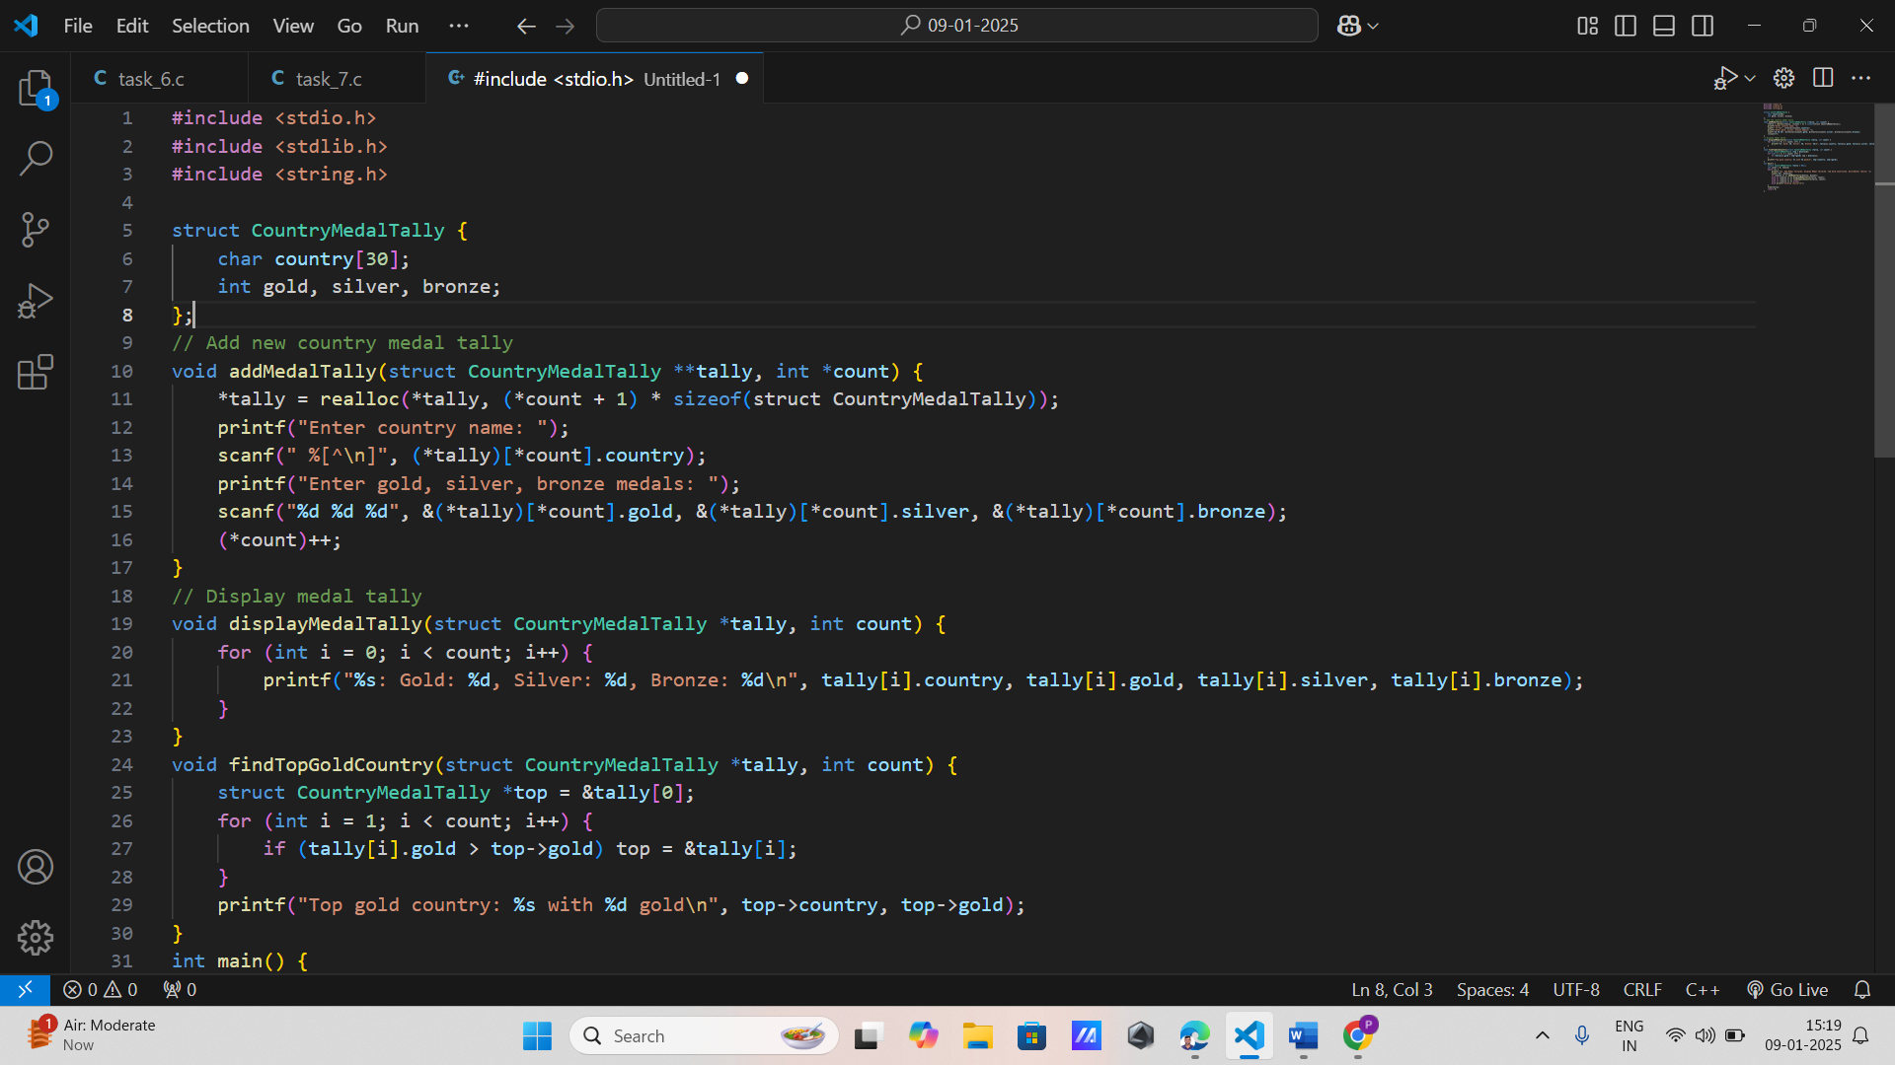

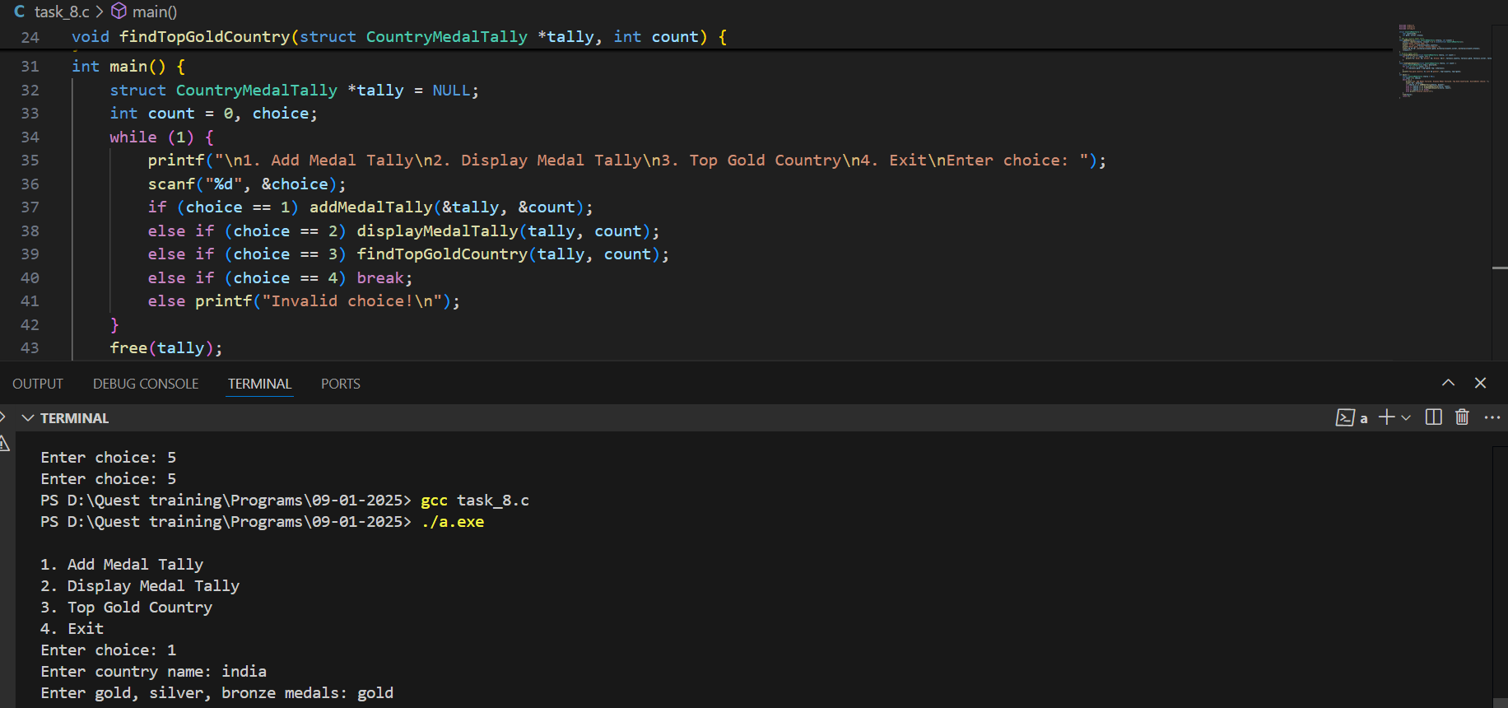

**Problem 4: Athlete Performance Tracker**

**Requirements:**

* Create a structure Athlete with fields:
  + char athleteID[10]
  + char name[50]
  + char sport[30]
  + float personalBest
  + float lastPerformance

**Functions to:**

* Add a new athlete to the system.
* Update an athlete's last performance.
* Display all athletes in a specific sport.
* Identify and display athletes who have set a new personal best in their last performance.
* Utilize dynamic memory allocation to manage athlete data in an expandable array.

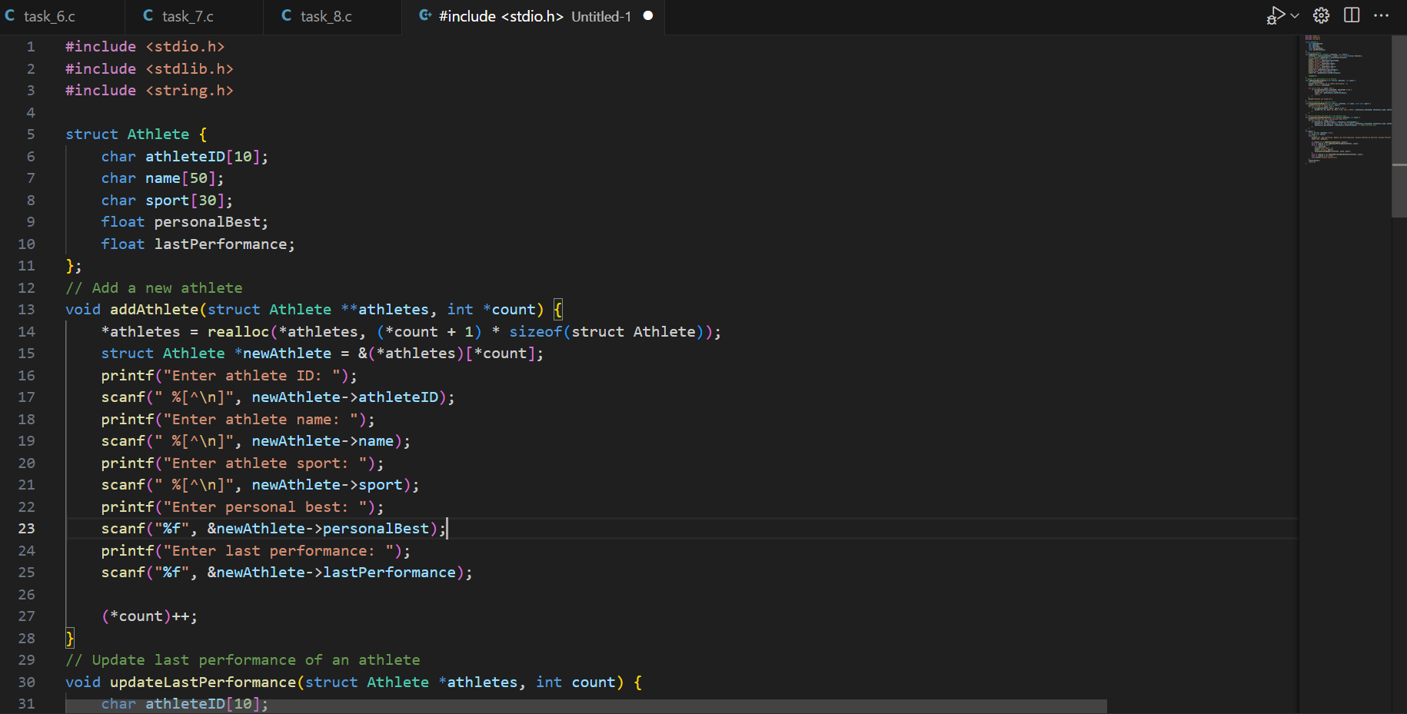

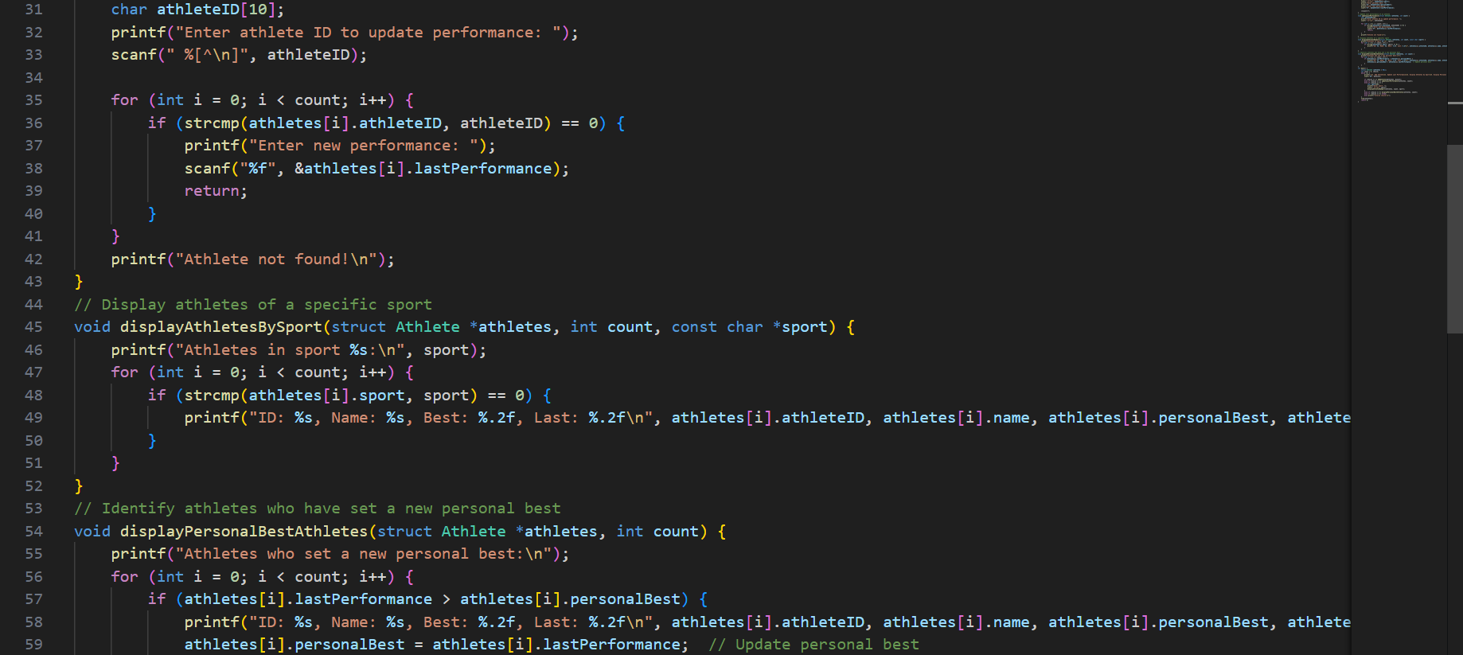

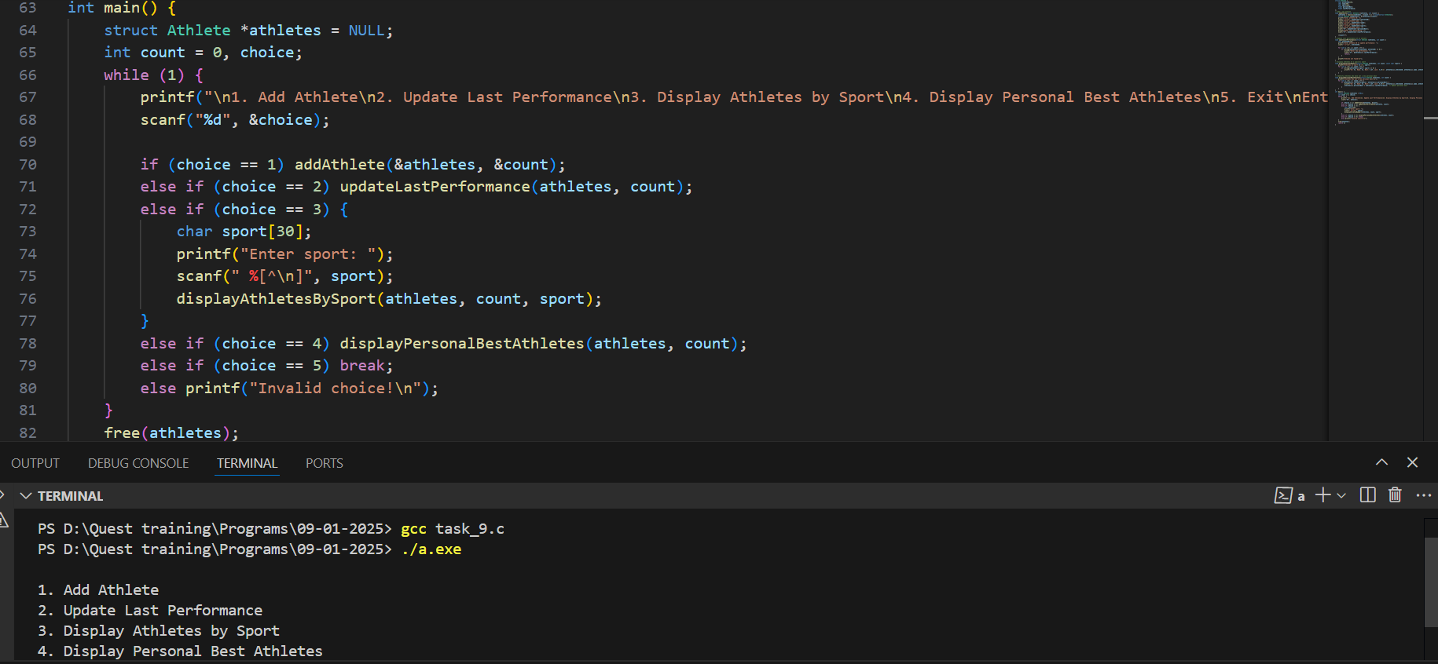

**Problem 5: Sports Equipment Inventory System**

**Requirements:**

* Define a structure Equipment with members:
  + char equipmentID[10]
  + char name[30]
  + char category[20] (e.g., balls, rackets)
  + int quantity
  + float pricePerUnit

**Functions to:**

* Add new equipment to the inventory.
* Update the quantity of existing equipment.
* Display all equipment in a specific category.
* Calculate the total value of equipment in the inventory.
* Store the inventory data in a dynamically allocated array and ensure proper resizing when needed.

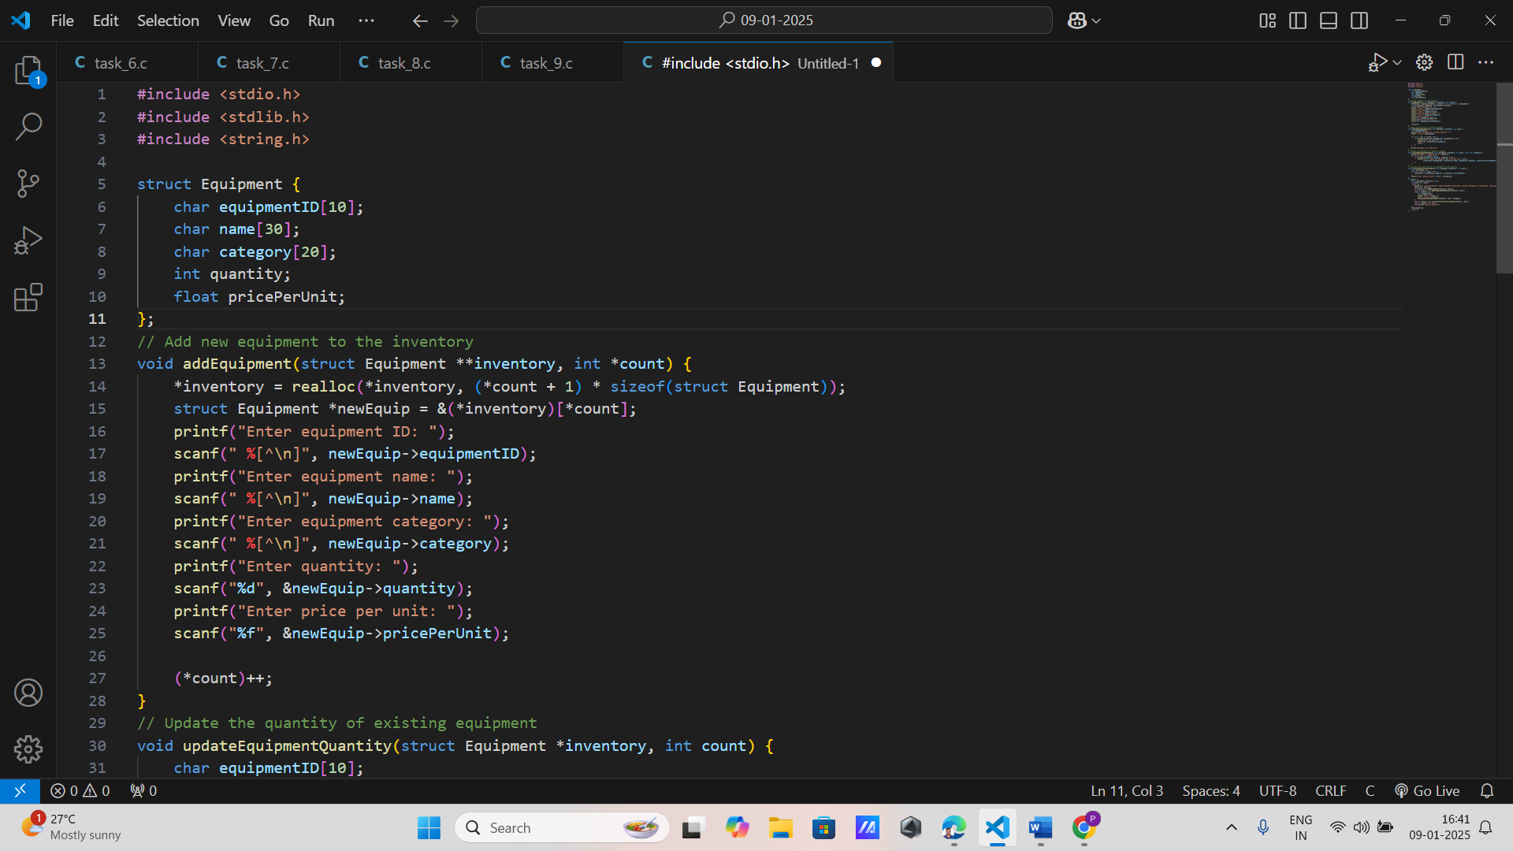

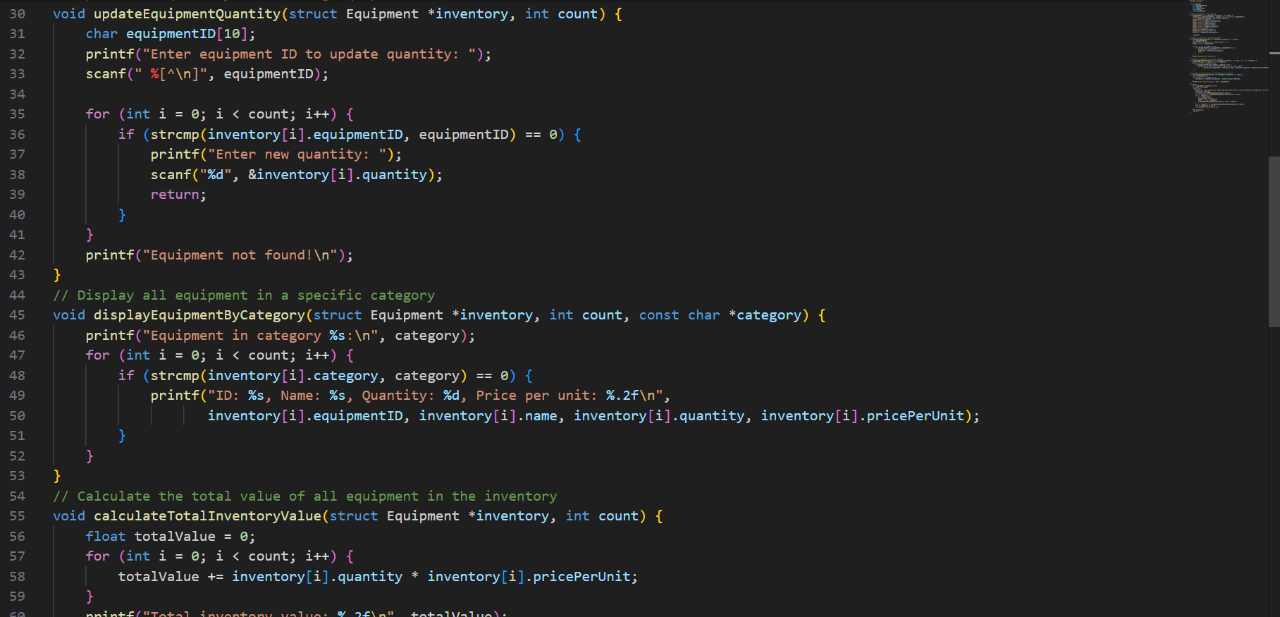

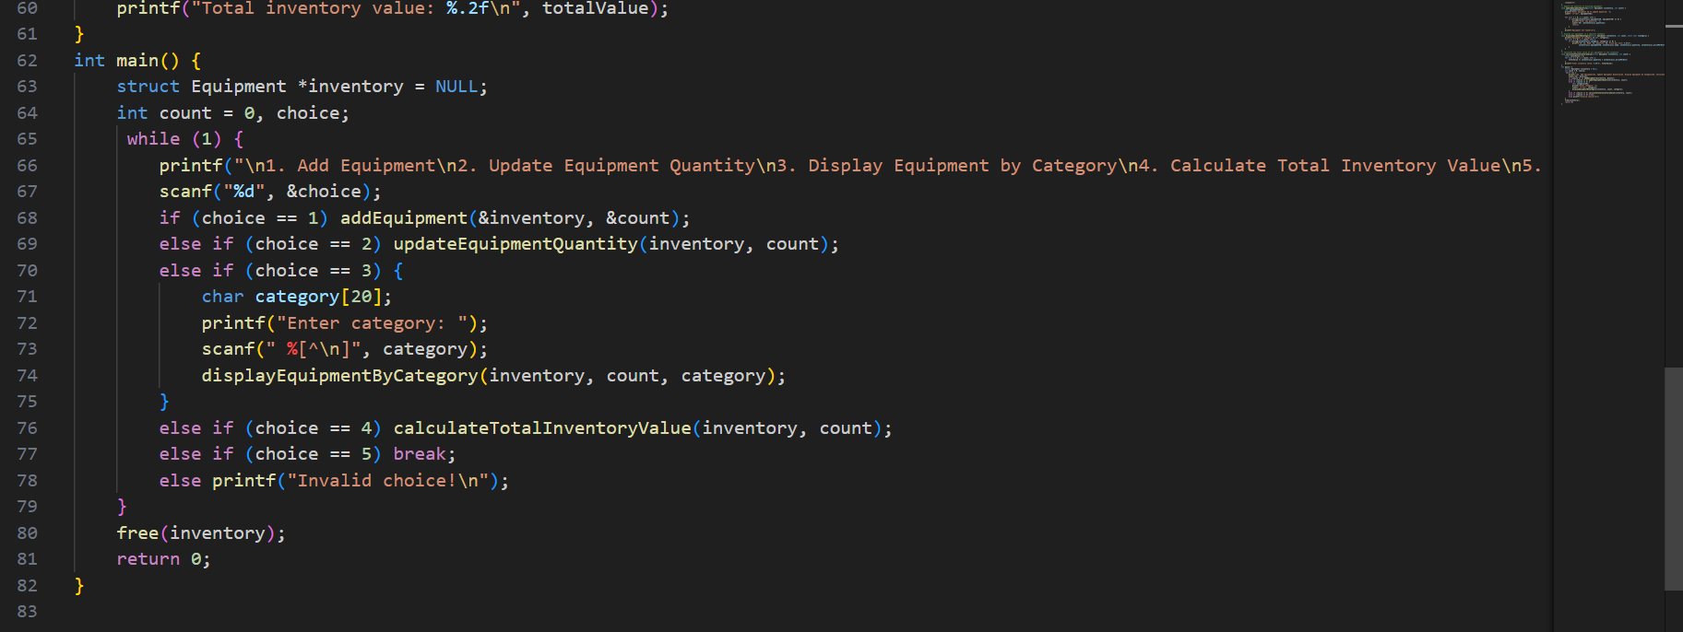

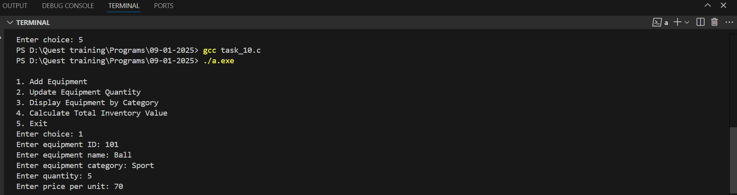

**Problem 1: Research Paper Database Management**

**Requirements:**

* Define a structure ResearchPaper with the following members:
  + char title[100]
  + char author[50]
  + char journal[50]
  + int year, char DOI[30]

**Functions to:**

* Add a new research paper to the database.
* Update the details of an existing paper using its DOI.
* Display all papers published in a specific journal.
* Find and display the most recent papers published by a specific author.
* Use dynamic memory allocation to store and manage the research papers in an array, resizing it as needed.

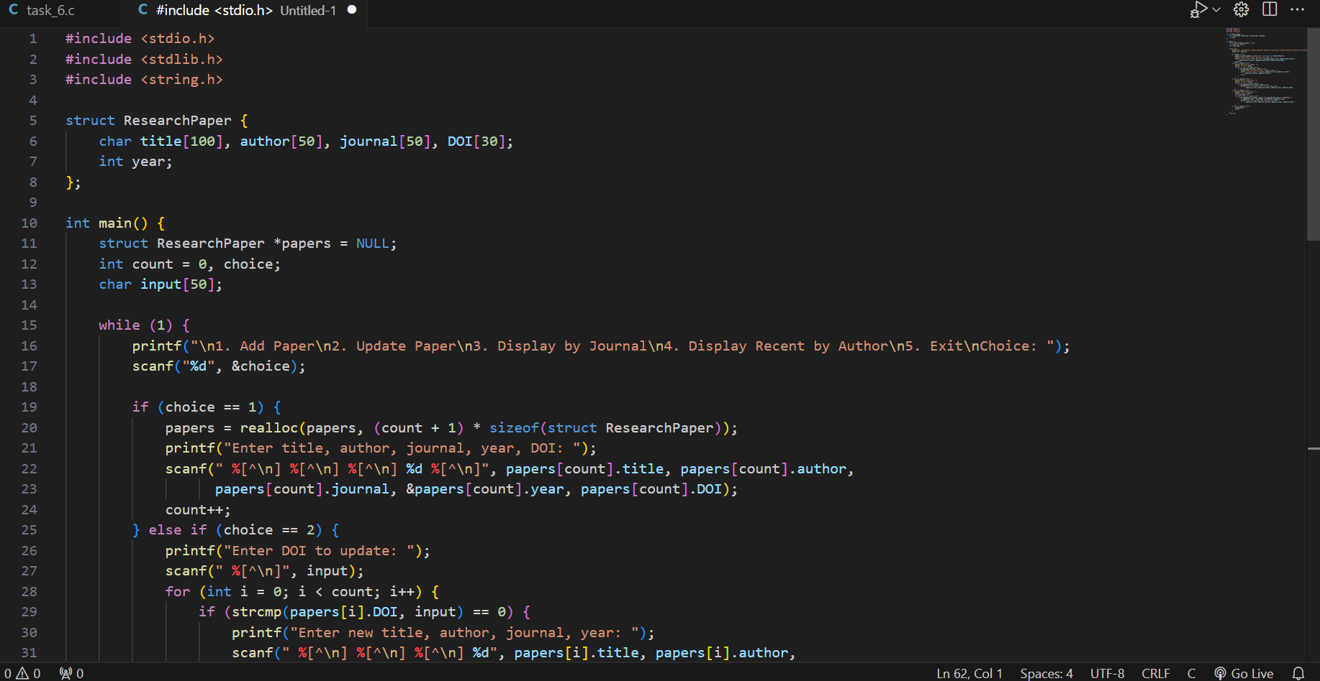

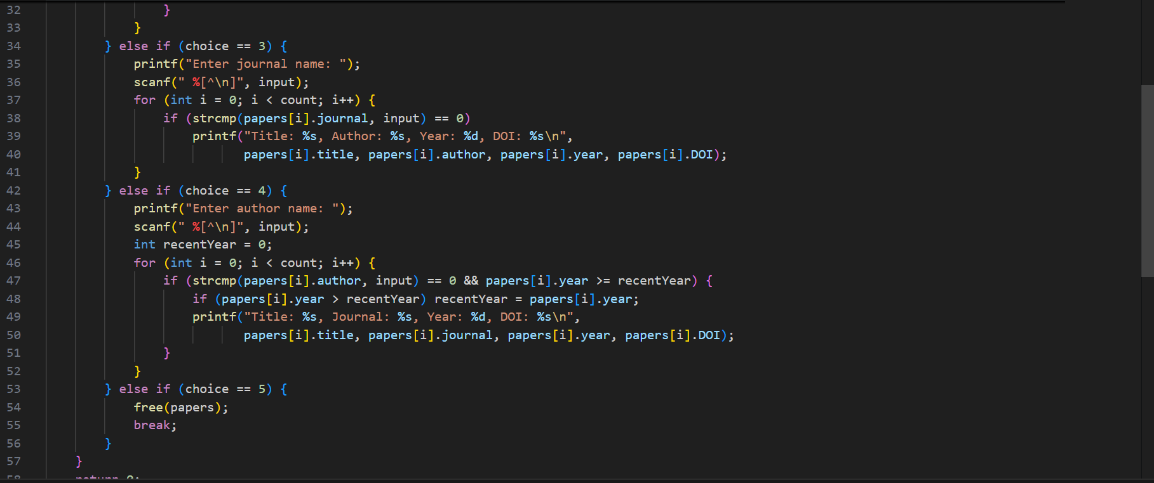

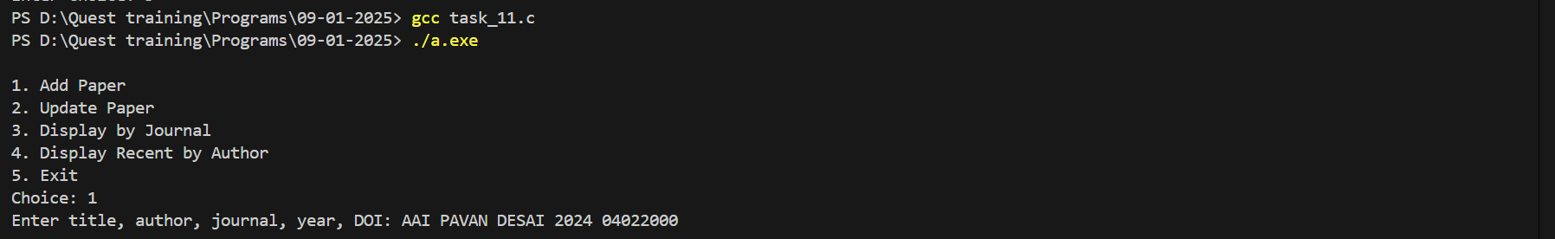

**Problem 2: Experimental Data Logger**

**Requirements:**

* Create a structure Experiment with members:
  + char experimentID[10]
  + char researcher[50]
  + char startDate[11] (format: YYYY-MM-DD)
  + char endDate[11]
  + float results[10] (store up to 10 result readings)

**Functions to:**

* Log a new experiment.
* Update the result readings of an experiment.
* Display all experiments conducted by a specific researcher.
* Calculate and display the average result for a specific experiment.
* Use a dynamically allocated array for storing experiments and manage resizing as more data is logged.

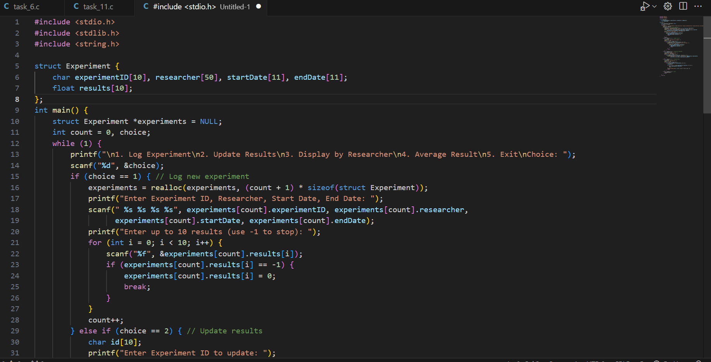

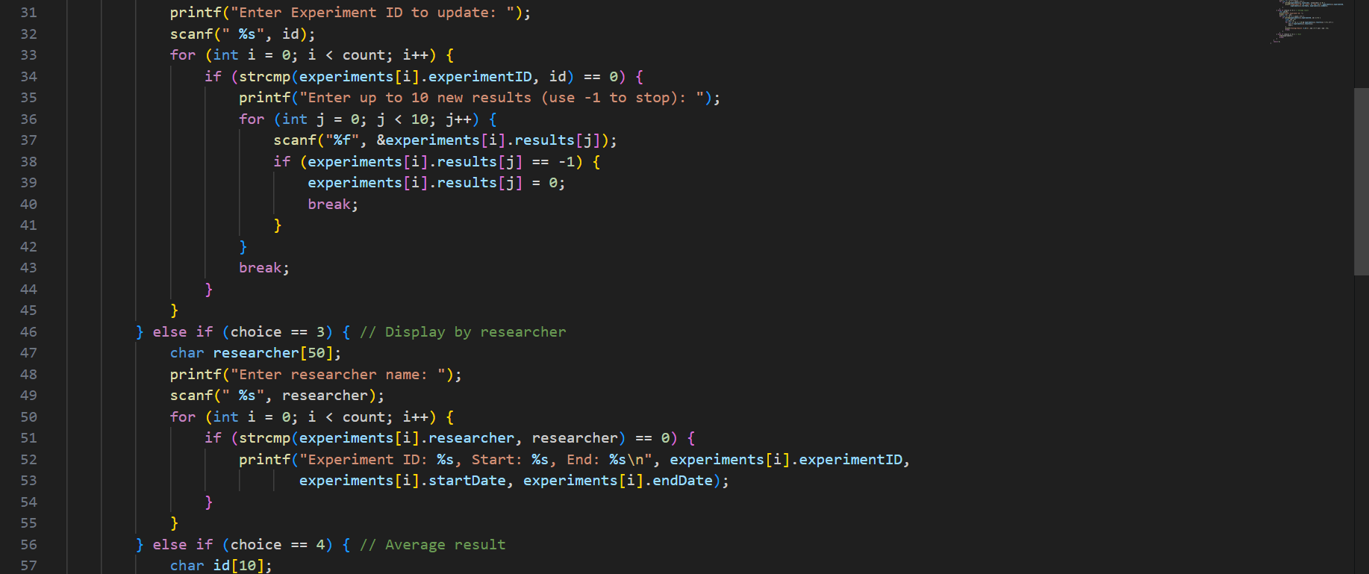

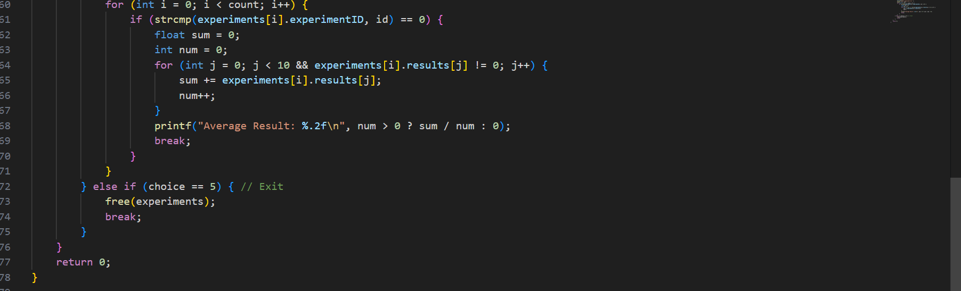

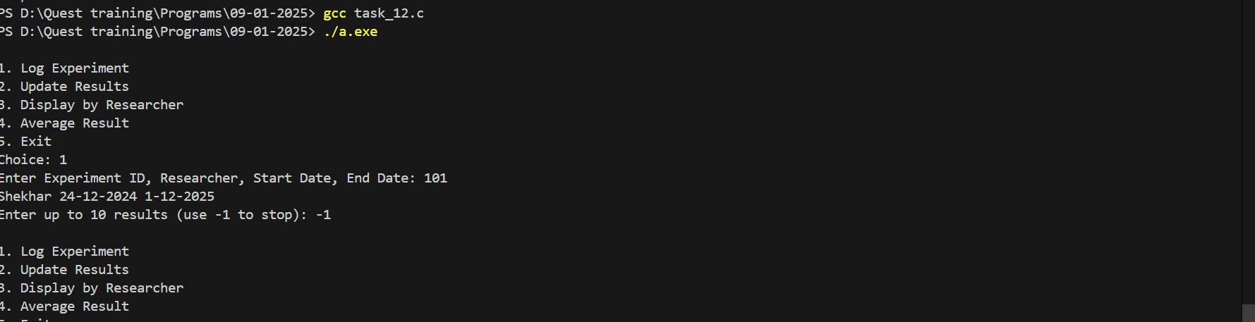

**Problem 3: Grant Application Tracker**

**Requirements:**

* Define a structure GrantApplication with the following members:
  + char applicationID[10]
  + char applicantName[50]
  + char projectTitle[100]
  + float requestedAmount
  + char status[20] (e.g., Submitted, Approved, Rejected)

**Functions to:**

* Add a new grant application.
* Update the status of an application.
* Display all applications requesting an amount greater than a specified value.
* Find and display applications that are currently "Approved."
* Store the grant applications in a dynamically allocated array, resizing it as necessary.

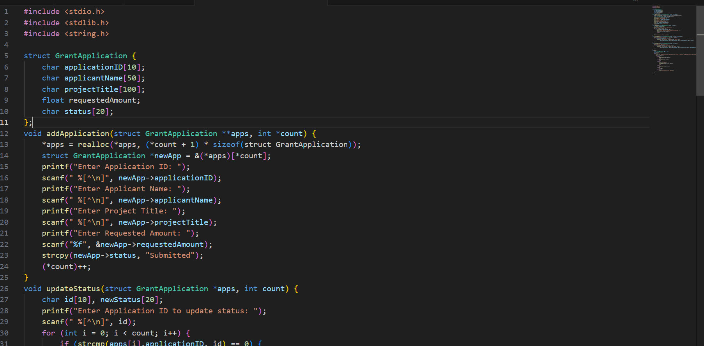

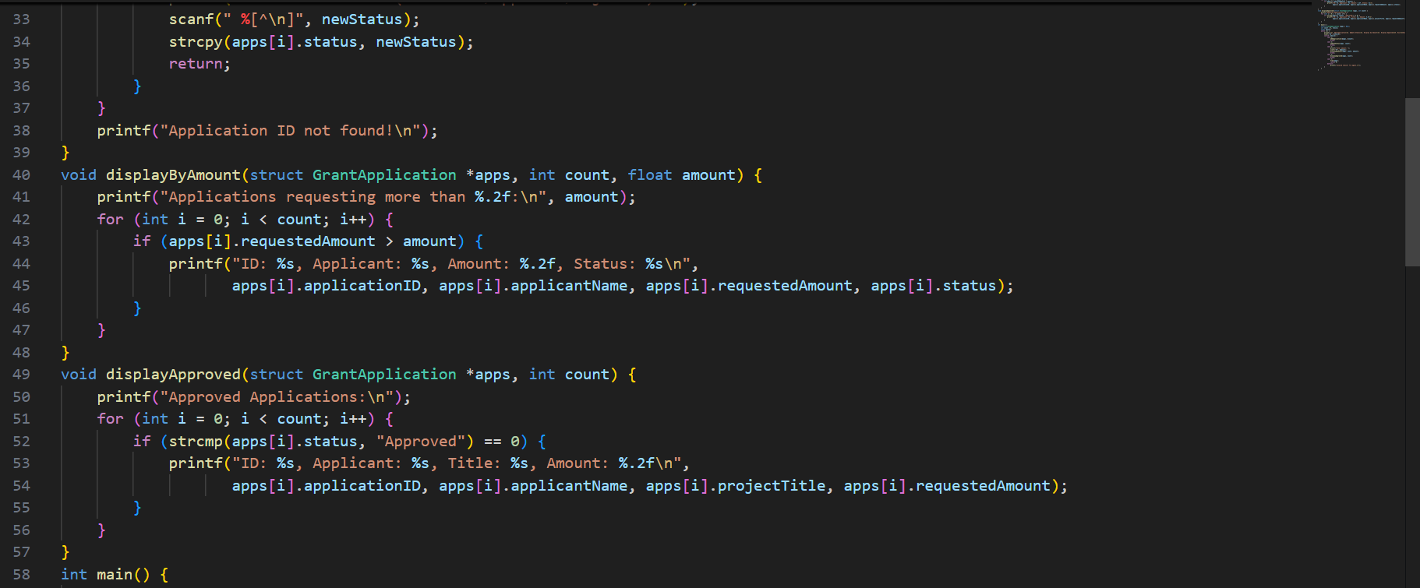

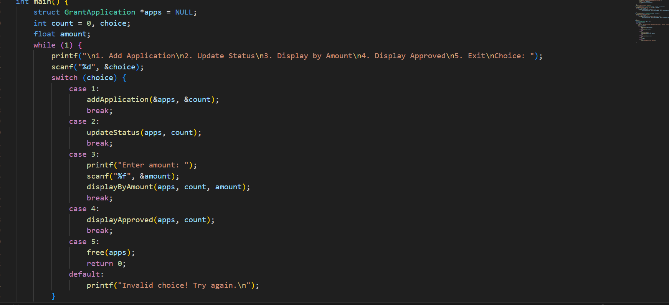

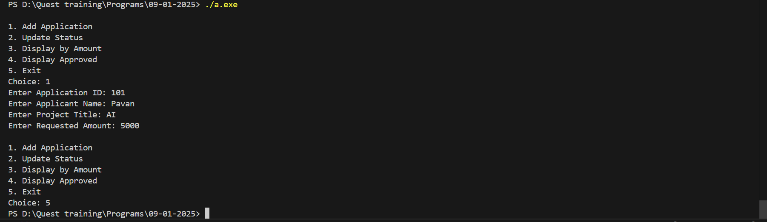

**Problem 4: Research Collaborator Management**

**Requirements:**

* Create a structure Collaborator with members:
  + char collaboratorID[10]
  + char name[50]
  + char institution[50]
  + char expertiseArea[30]
  + int numberOfProjects

**Functions to:**

* Add a new collaborator to the database.
* Update the number of projects a collaborator is involved in.
* Display all collaborators from a specific institution.
* Find collaborators with expertise in a given area.
* Use dynamic memory allocation to manage the list of collaborators, allowing for expansion as more are added.

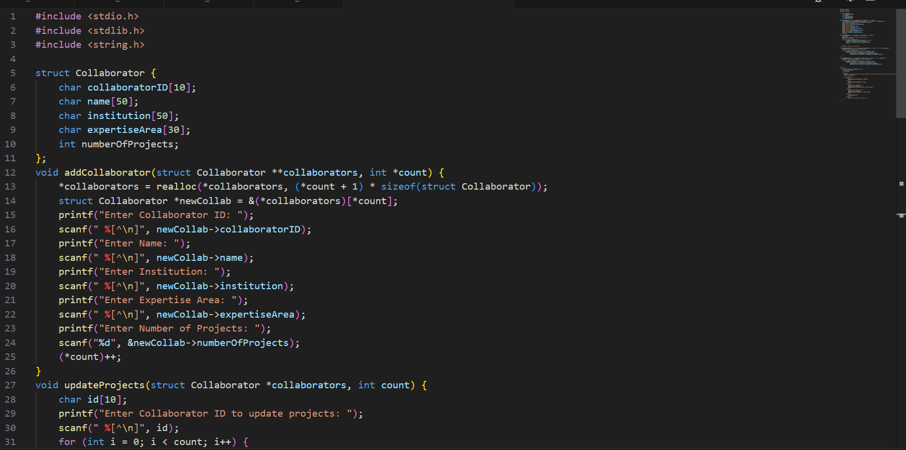

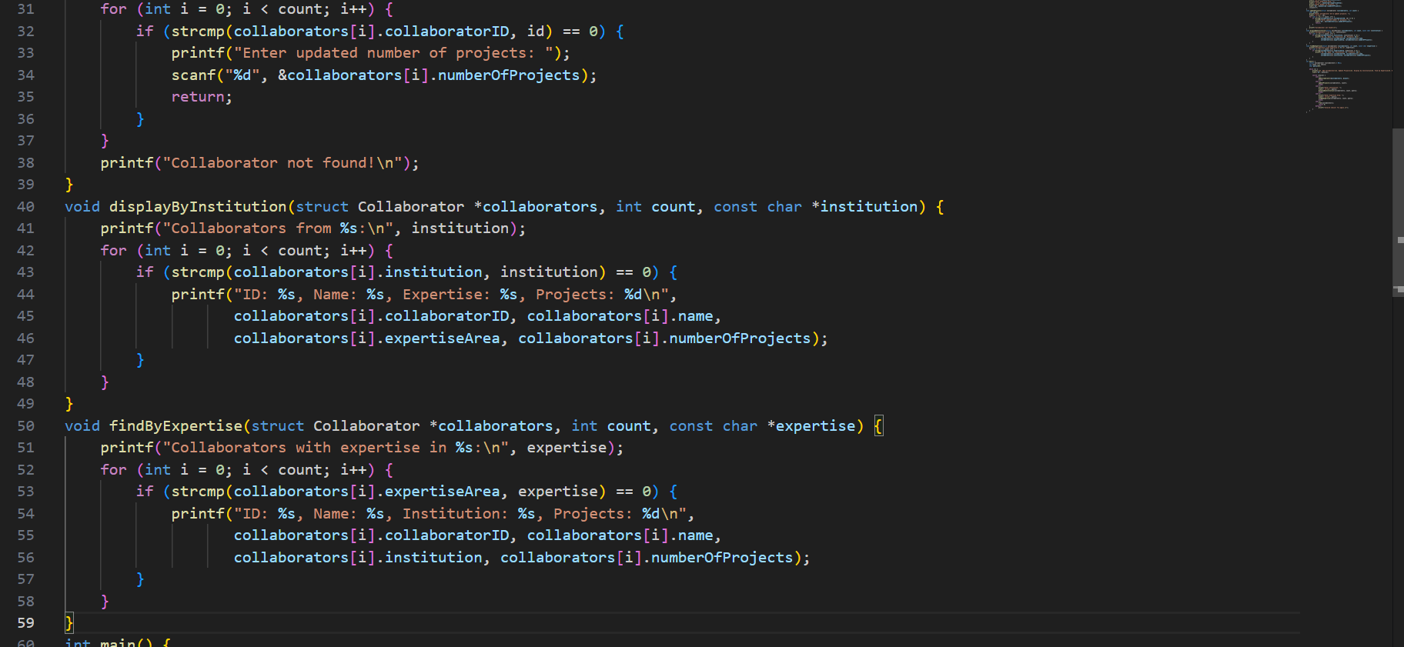

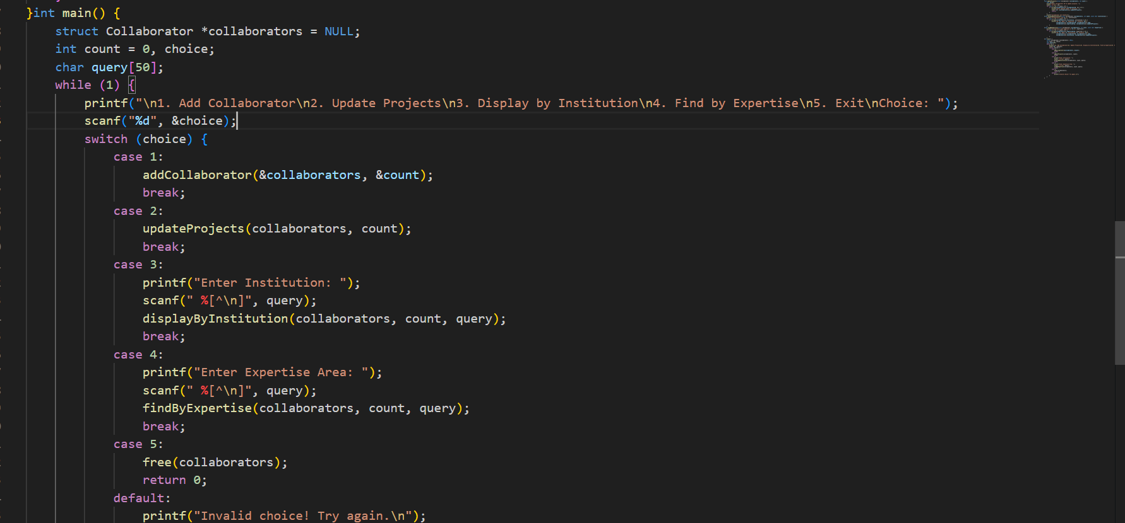

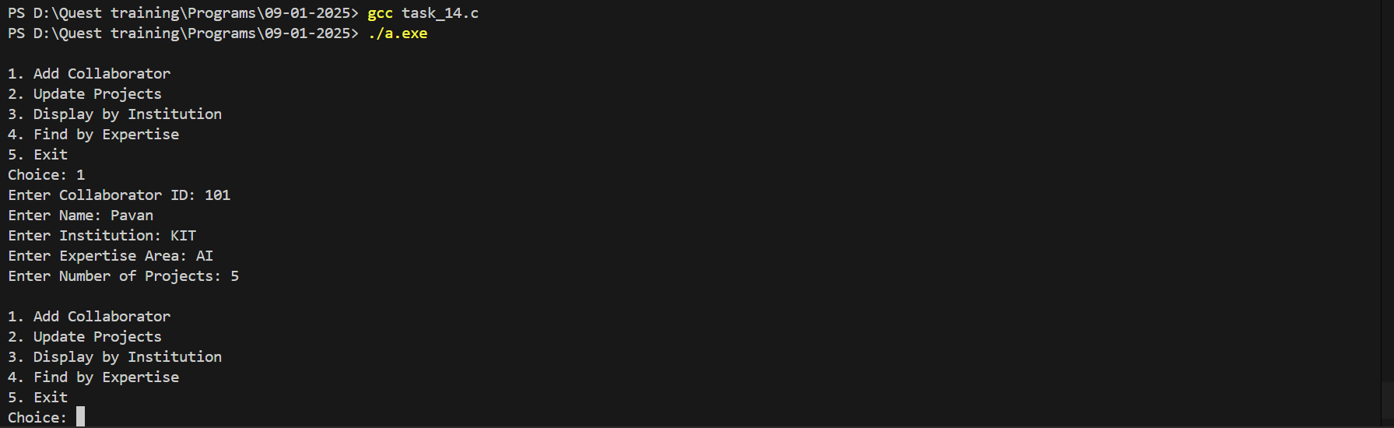

**Problem 5: Scientific Conference Submission Tracker**

**Requirements:** Define a structure ConferenceSubmission with the following:

* + char submissionID[10], char authorName[50], char paperTitle[100]
  + char conferenceName[50], char submissionDate[11],char status[20] (e.g., Pending, Accepted, Rejected)

**Functions to:**

* Add a new conference submission.
* Update the status of a submission.
* Display all submissions to a specific conference.
* Find and display submissions by a specific author.
* Store the conference submissions in a dynamically allocated array, resizing the array as needed when more submissions are added.

